**Project Name: ICIN Bank**

**Submitted by Seema Bhuyan**

Github link <https://github.com/Seema-beep/SimplilearnICINBankJobReadyProject.git>

User’s Portal Screenshots

# 1.) Registration Page

## a.) Personal details page

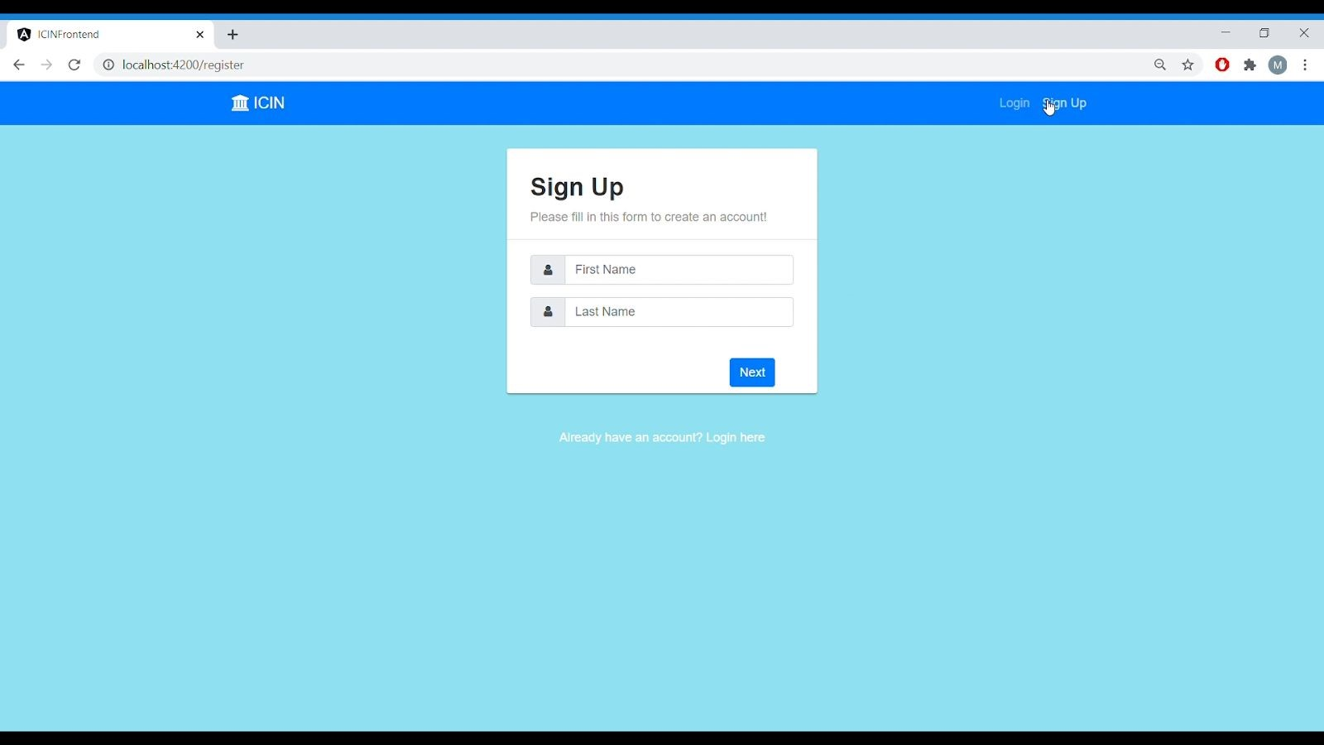

Fig.1. Personal Detail form

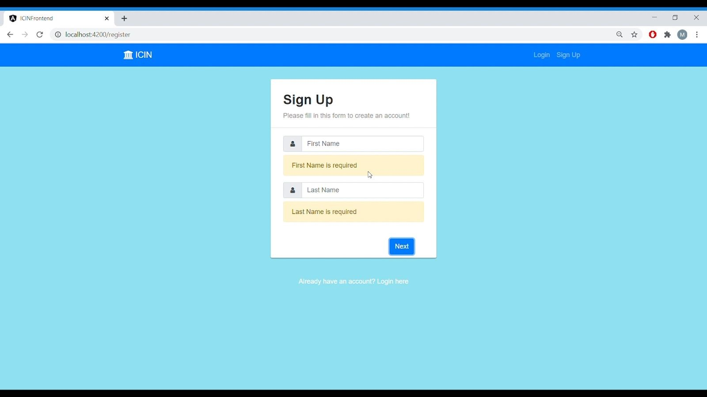

## Fig 2. Form Validation

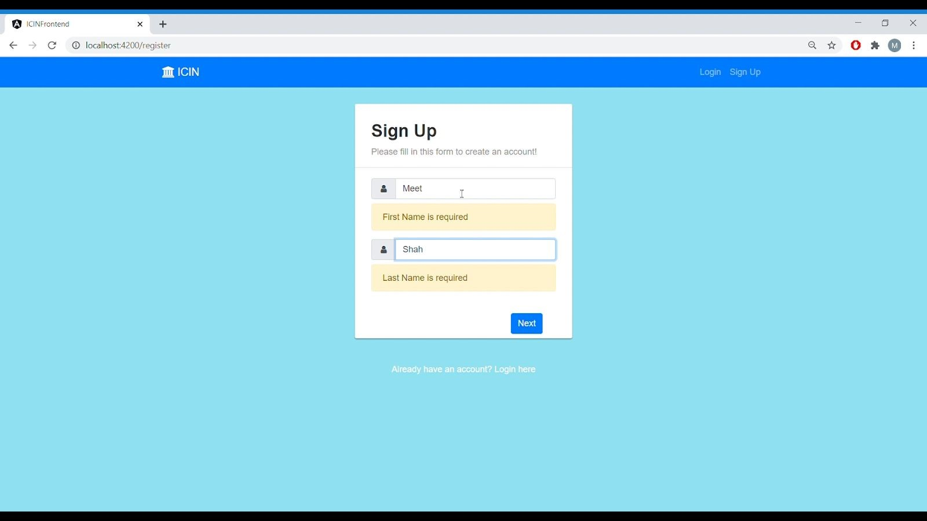

Fig 3. Personal Details

## b.) Contact Details

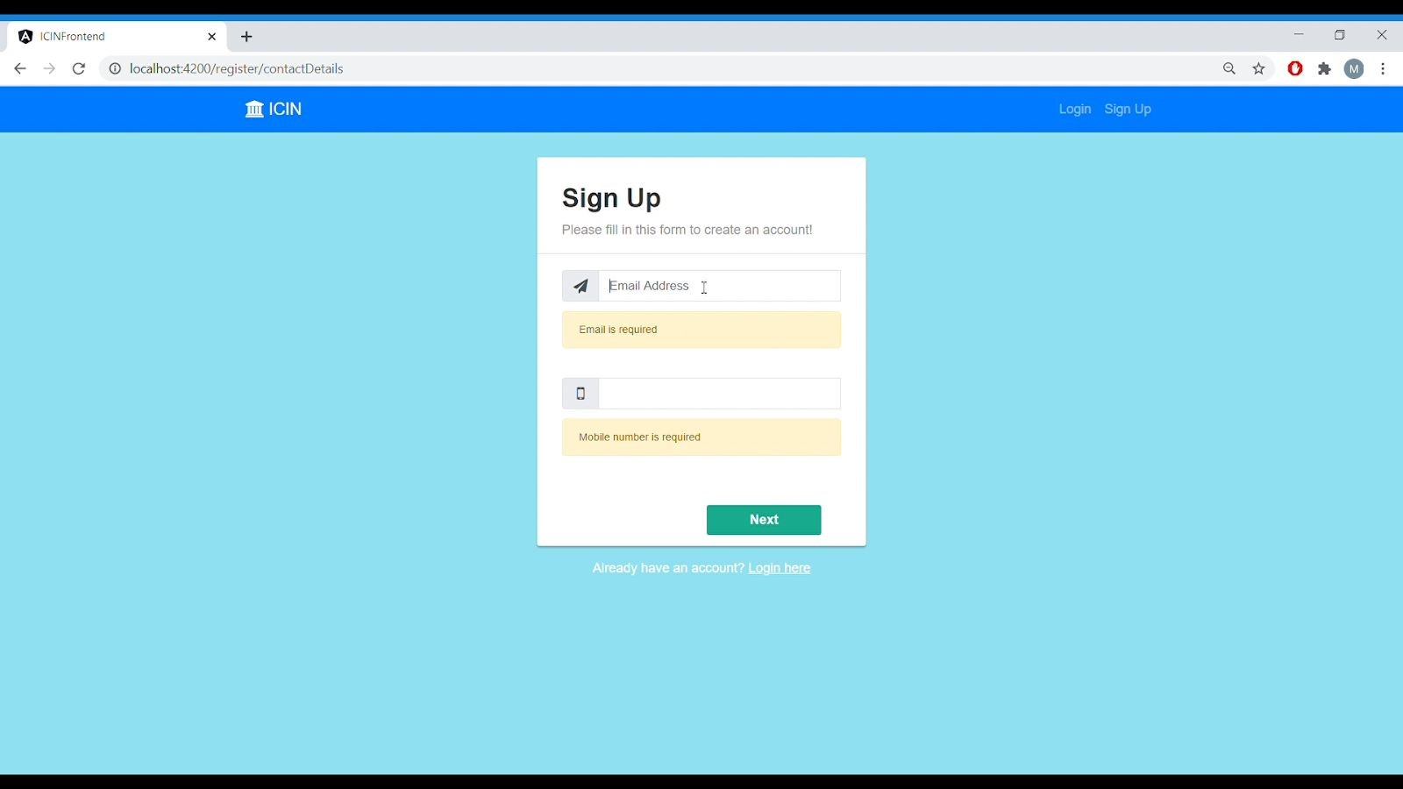

Fig 4. Contact Details form

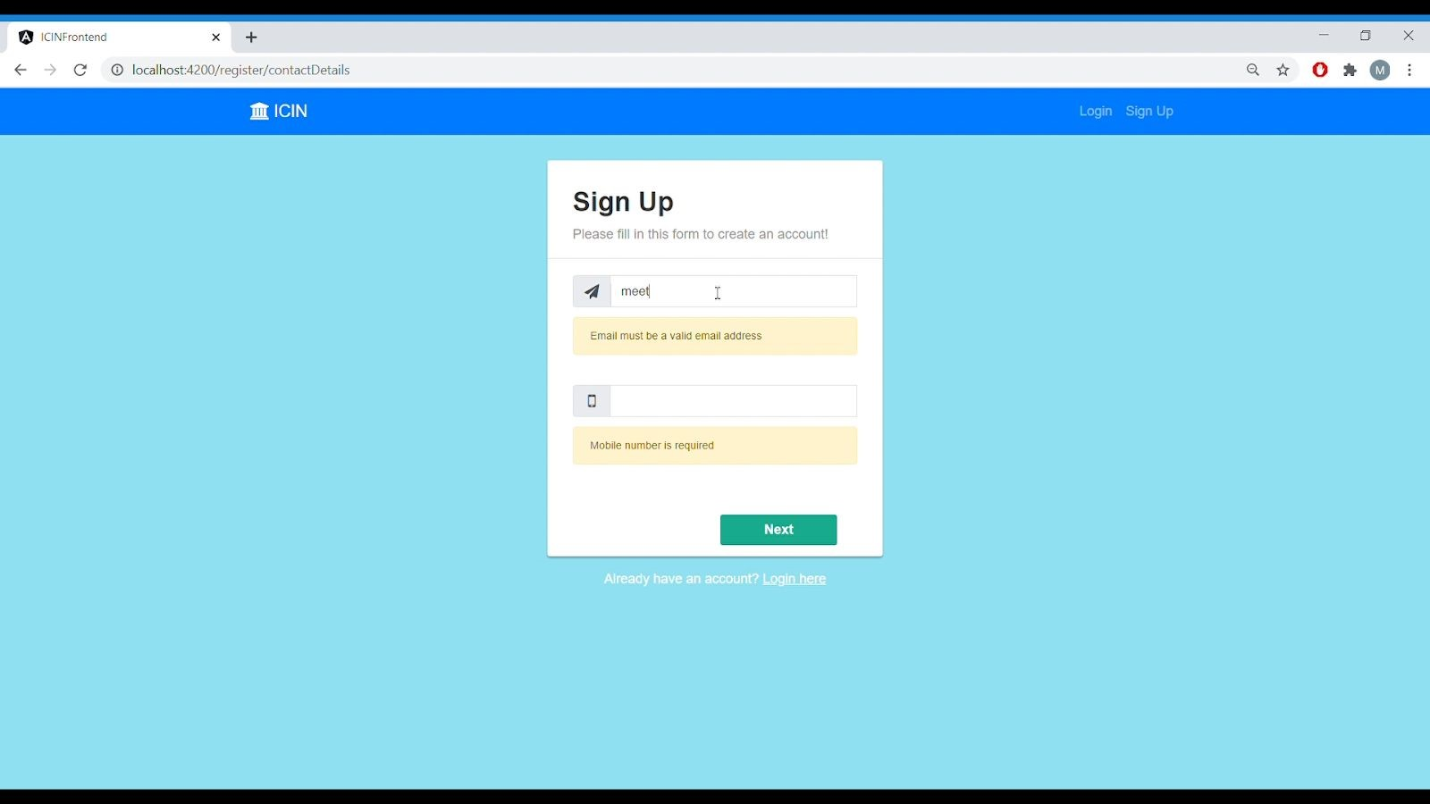

Fig 5. Email Validation

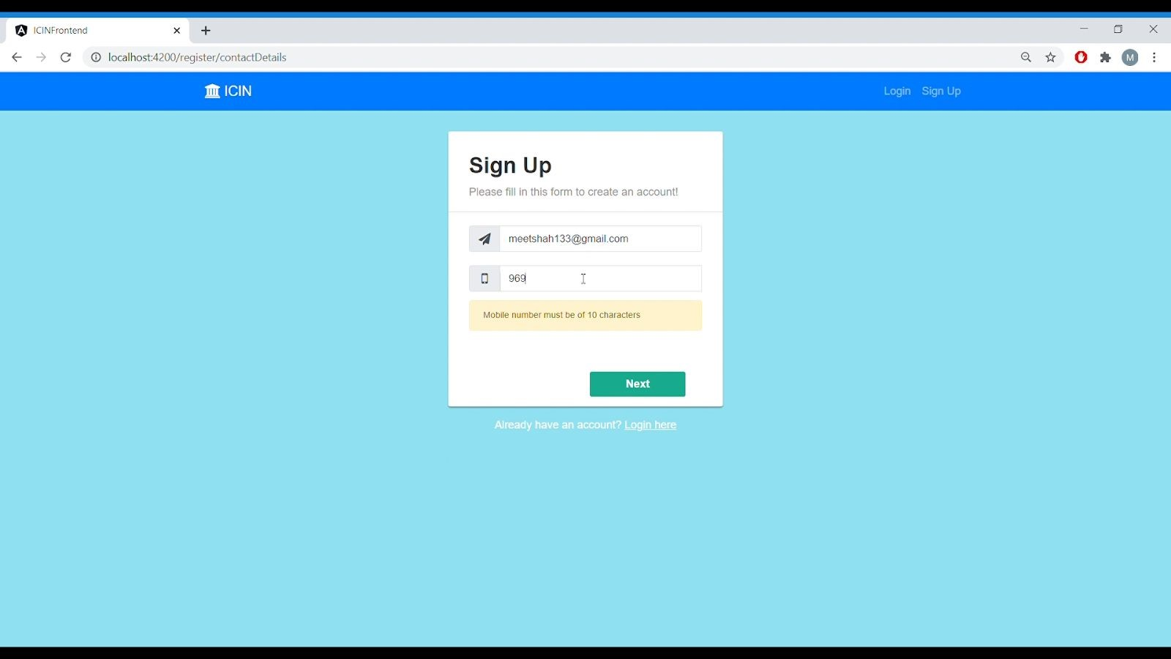

Fig 6. Mobile Number Validation

## c.)Kyc Details

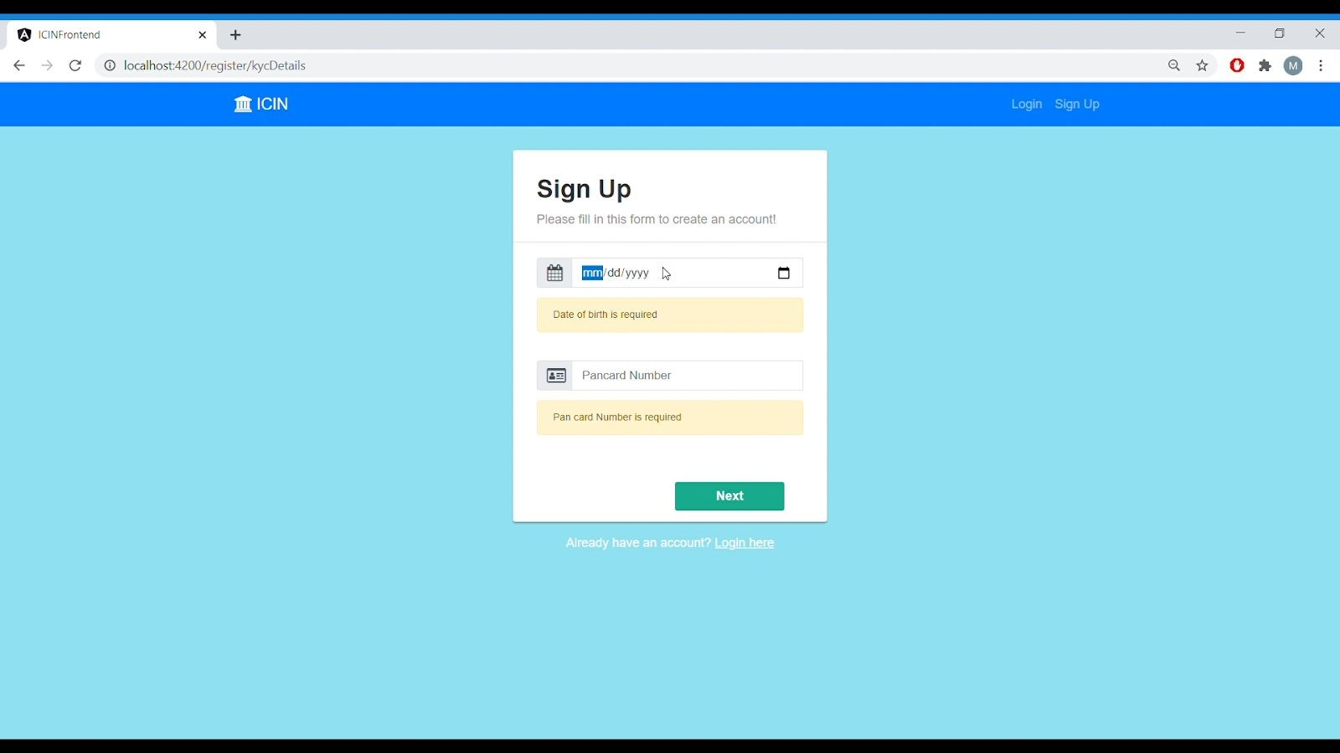

Fig 7: Kyc Details Form

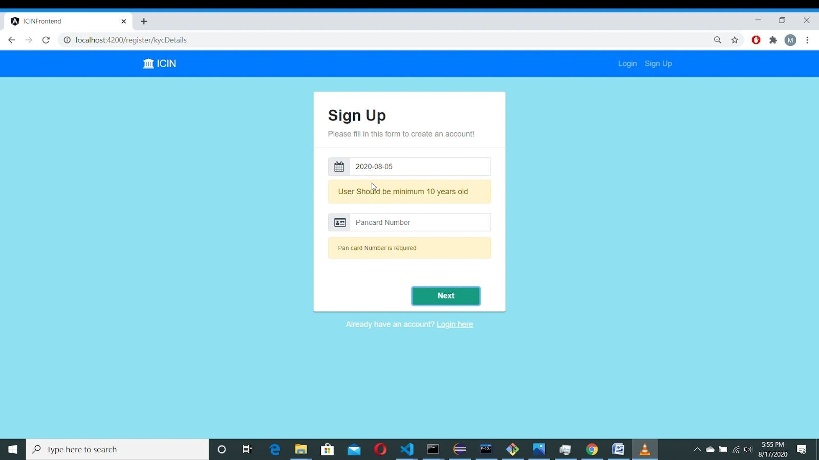

## Fig 8: Age Validation

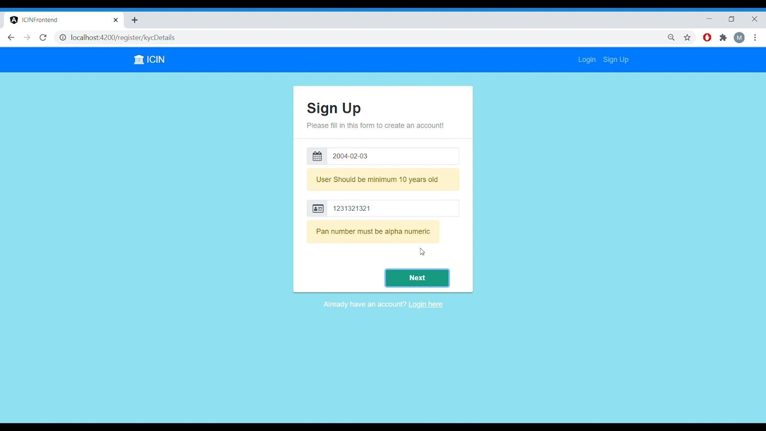

Fig 9: Pan Number Validation

## d.)Address Details

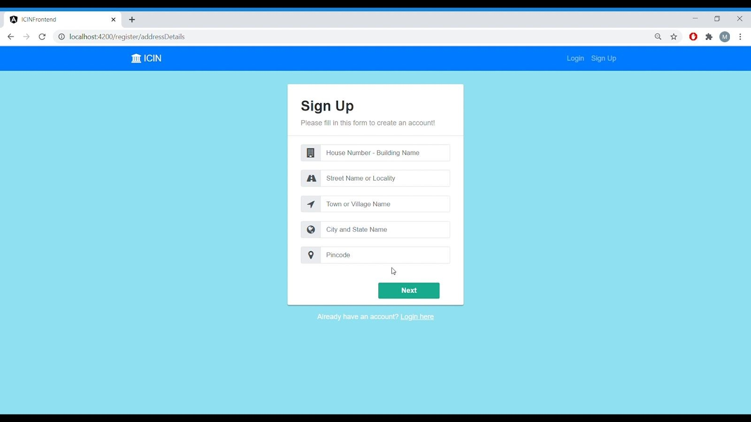

Fig. 10. Address Details Form

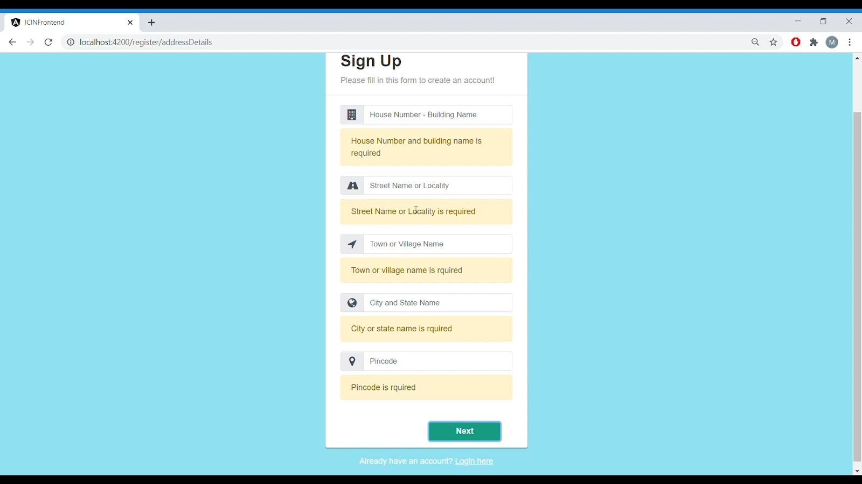

Fig 11. Form Validation

## e.) User Details Form

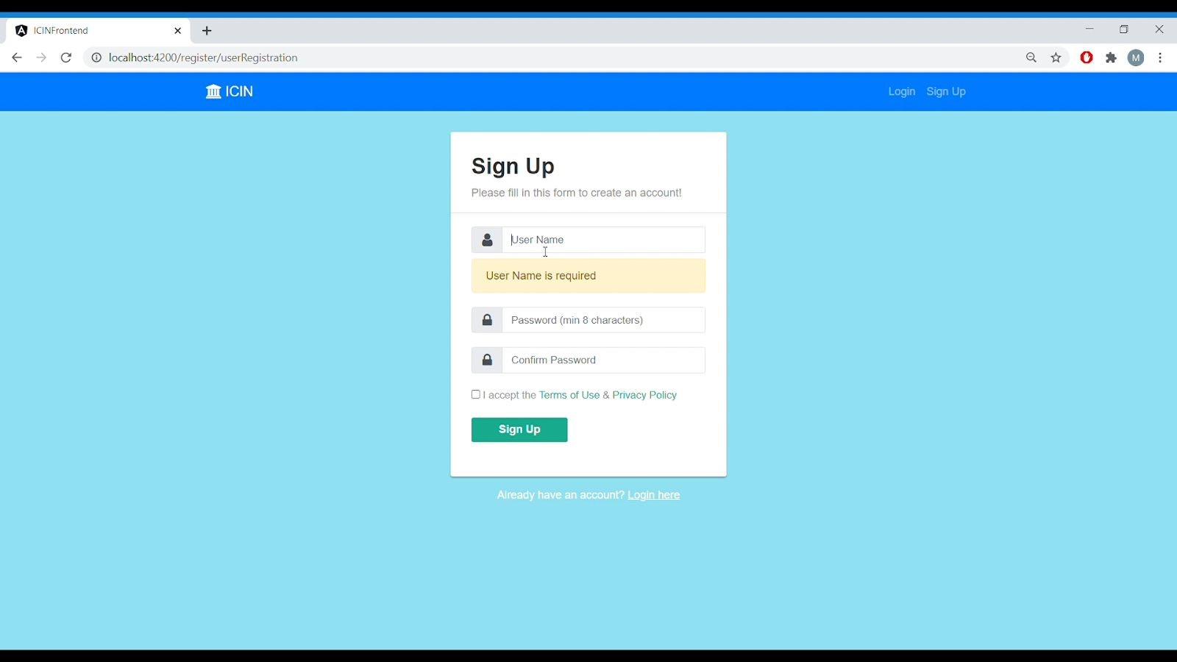

Fig 12. User Details Form

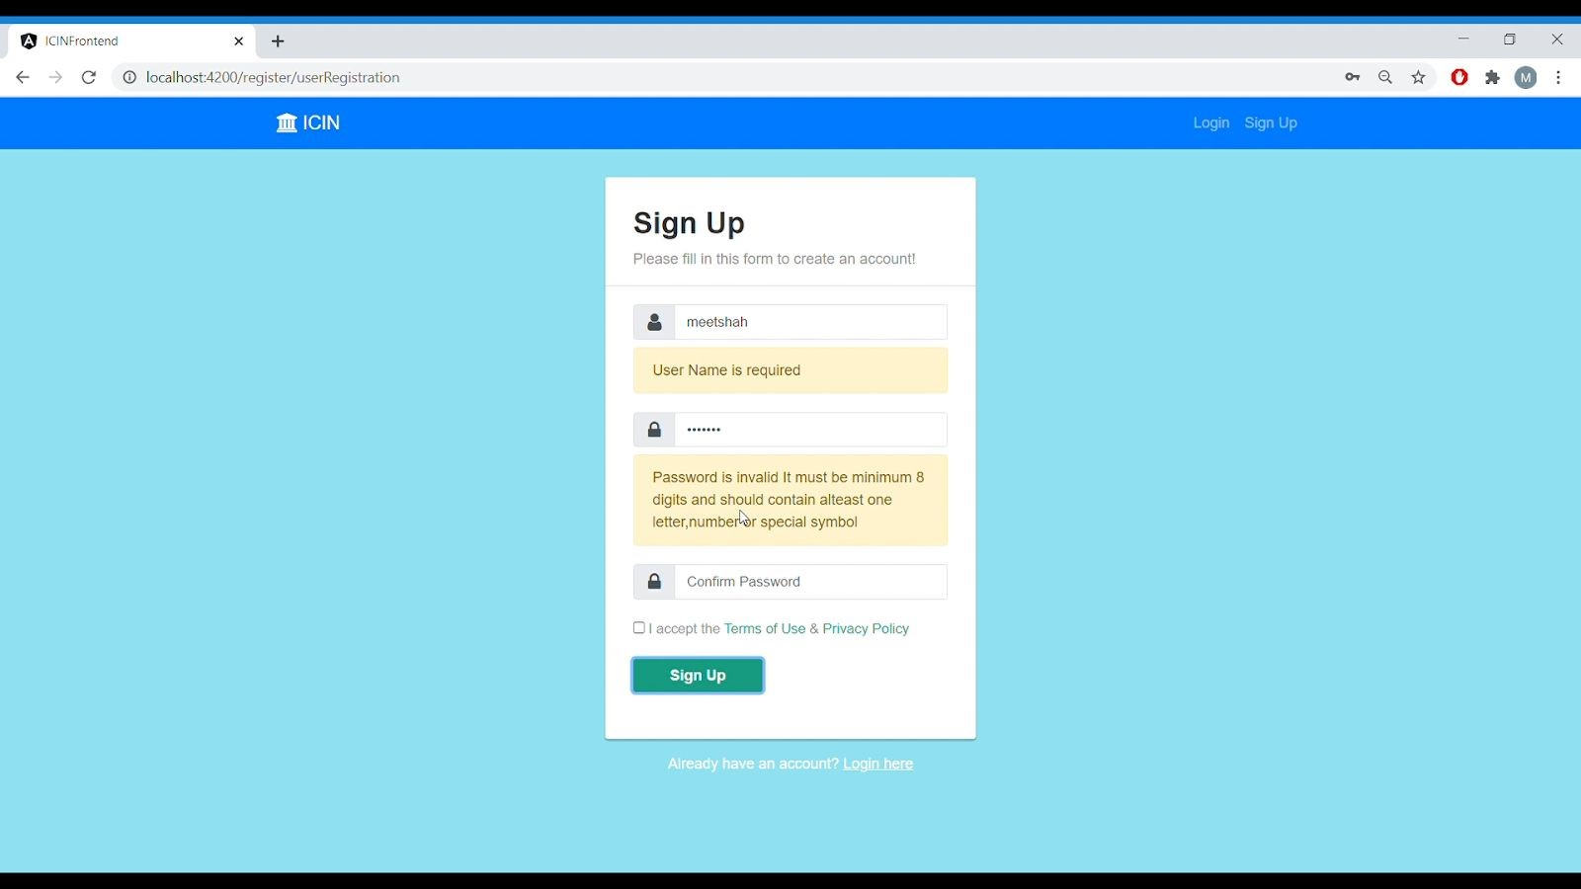

Fig 13. Password Validation

# 2.) Login Page

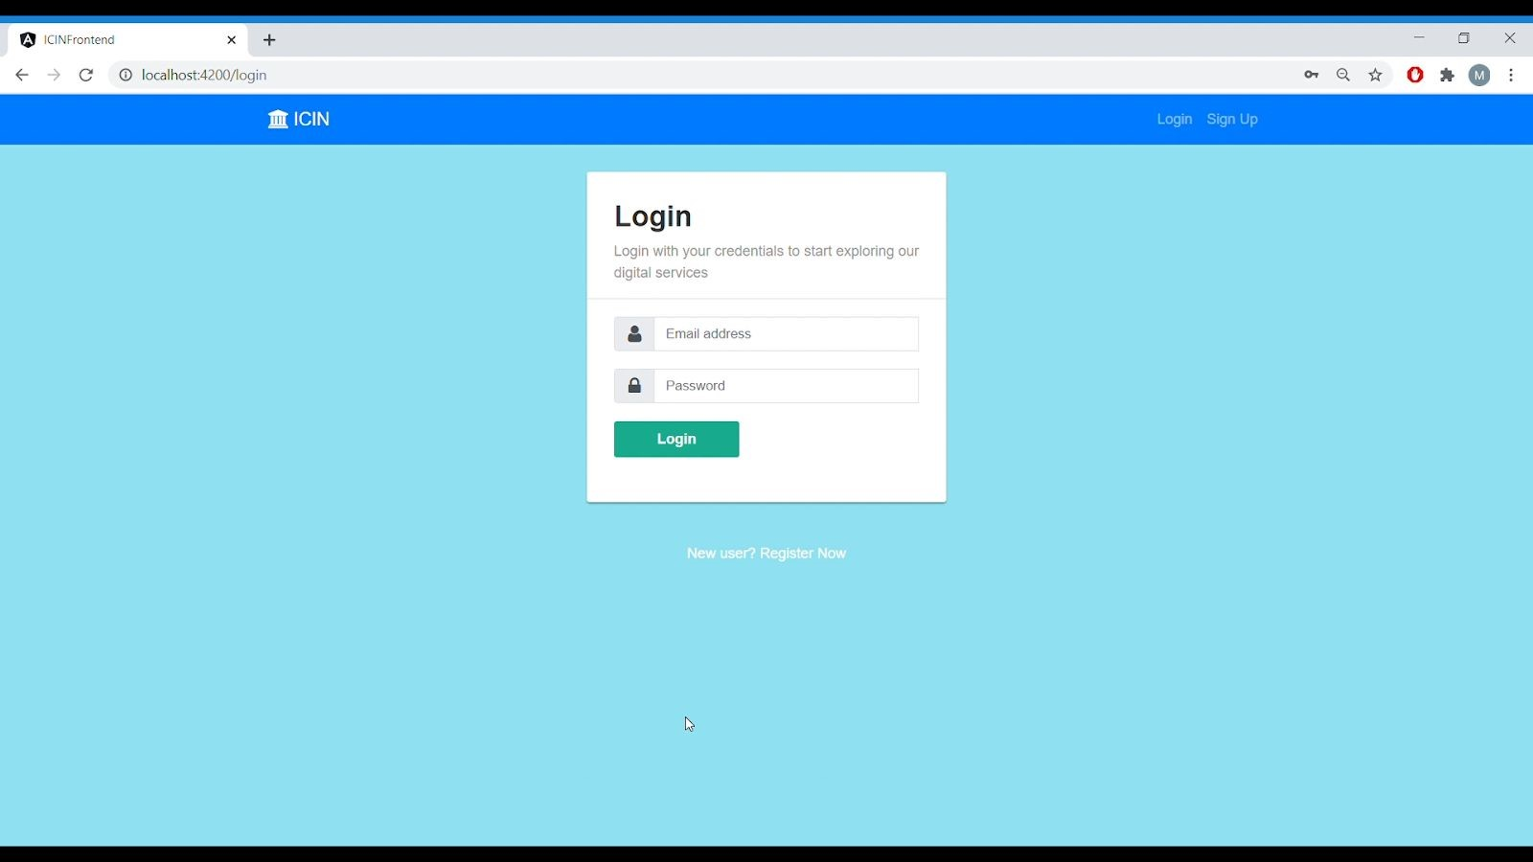

Fig 14. Login Form

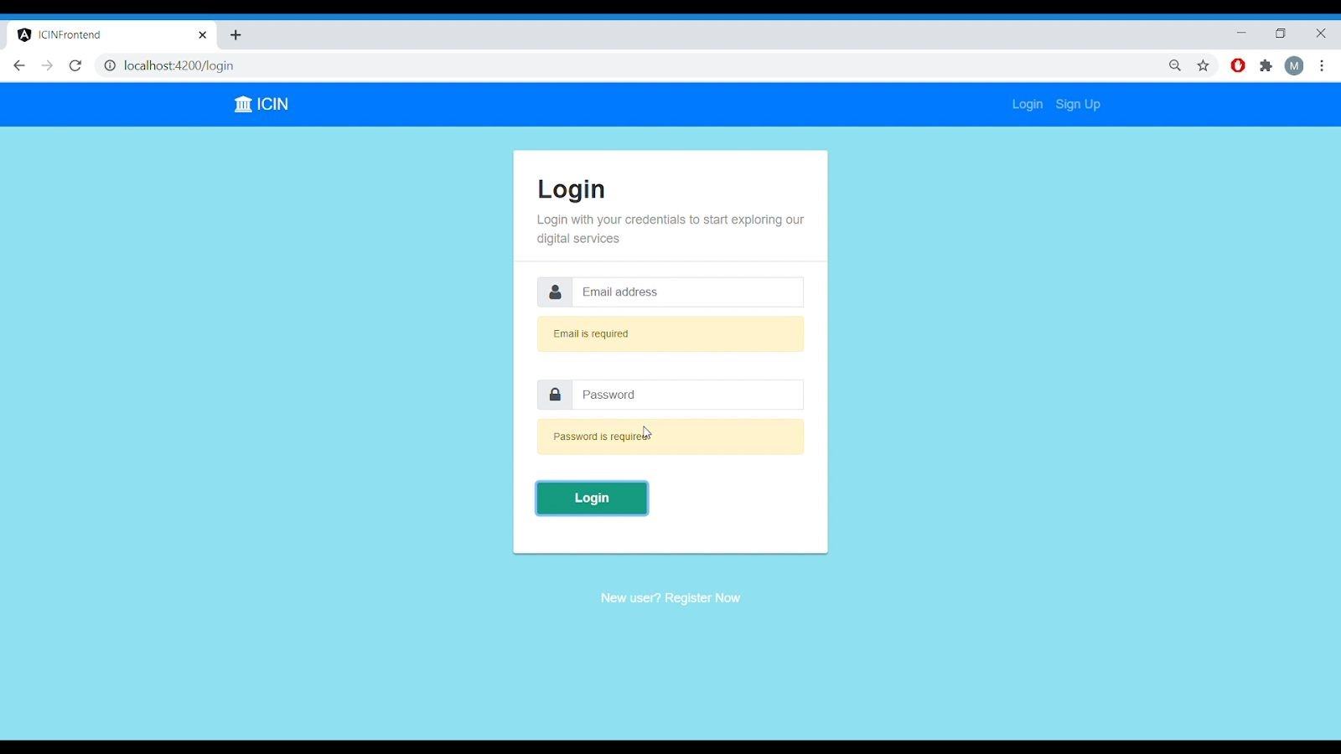

Fig 15. Login Form Validation

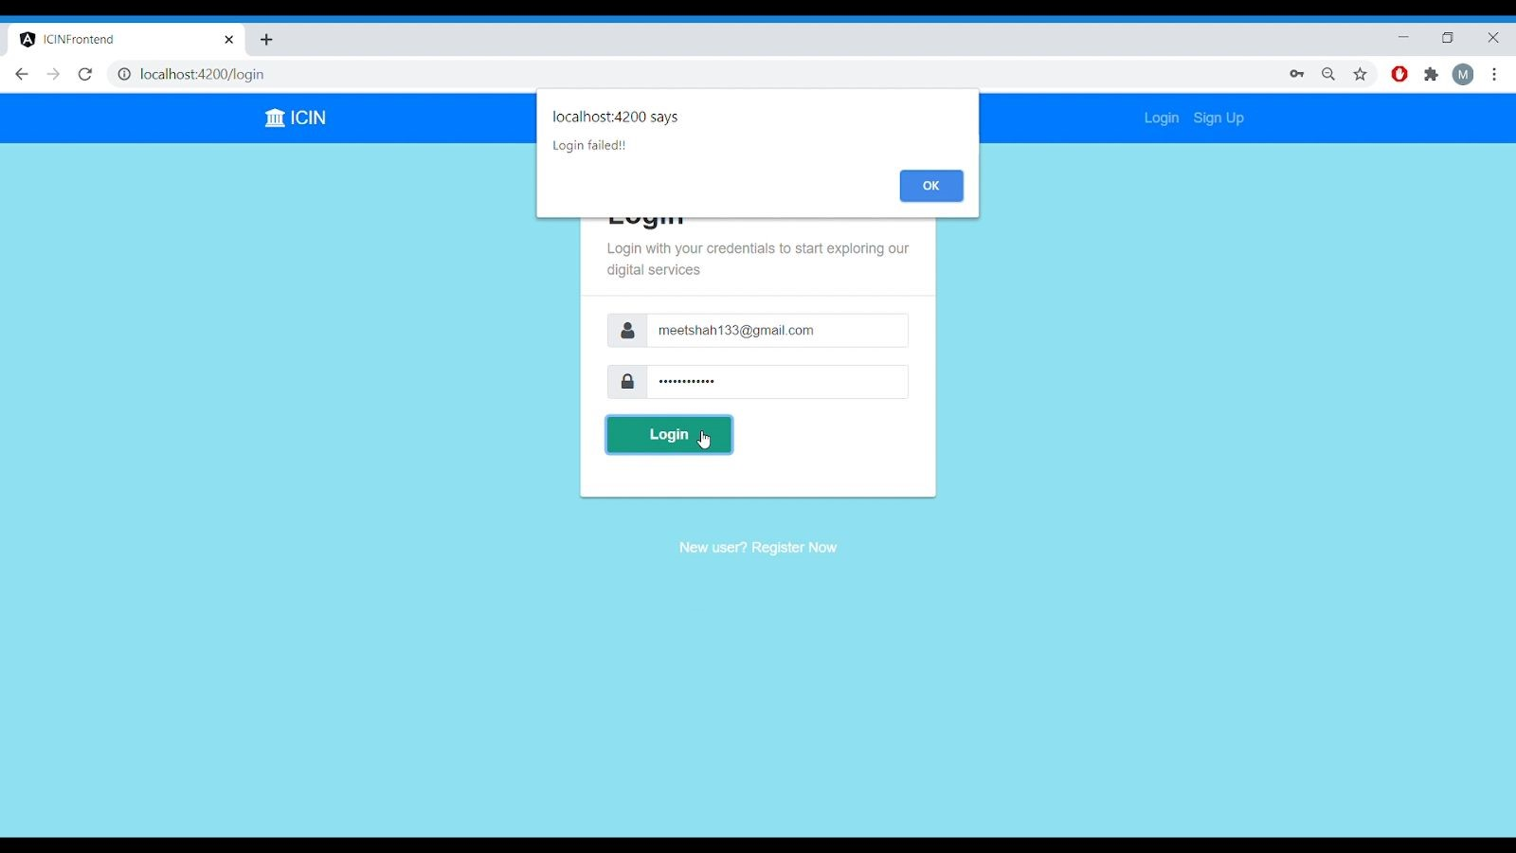

Fig 16. When user enters invalid credentials

# 3.) Home Page

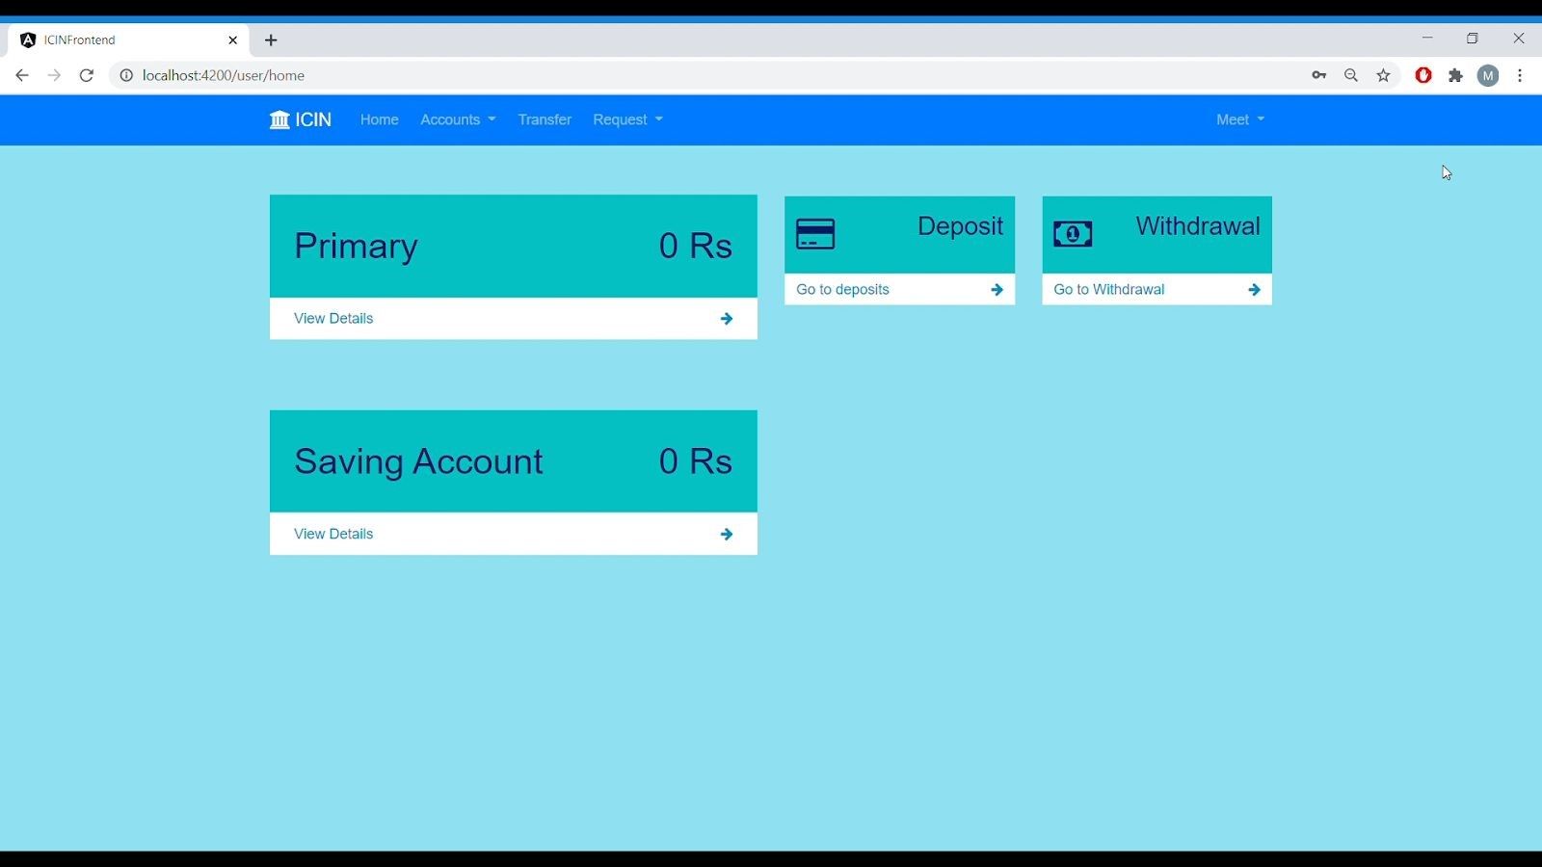

Fig 17. Home Page

# 4.) Deposit Fund Page

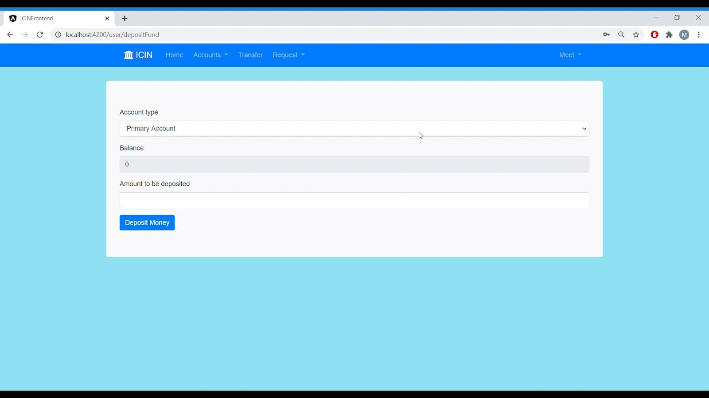

Fig 18. Deposit Fund Form



Fig 19. Depositing Money in primary account

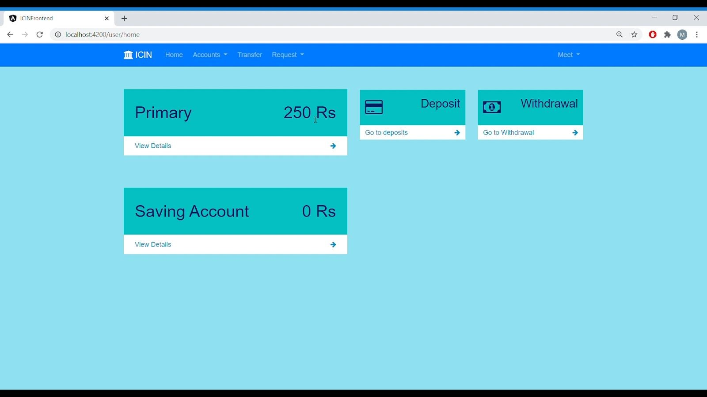

## Fig 20. Primary Account Balance Updated

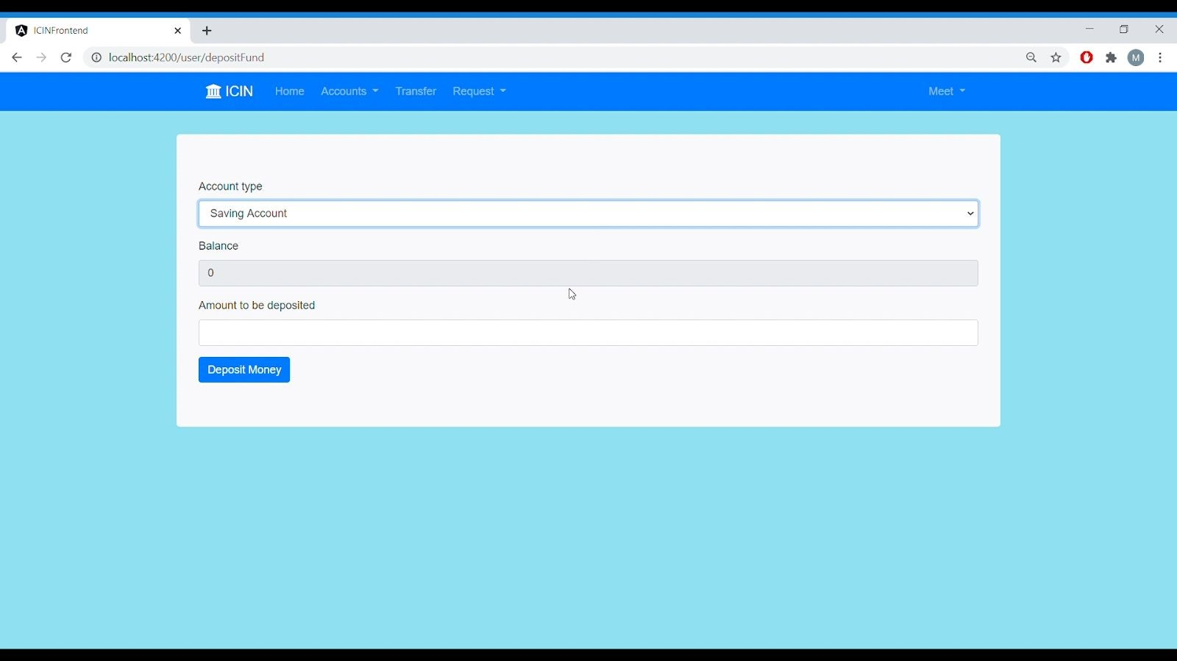

## Fig 21. Depositing Money in Saving Account

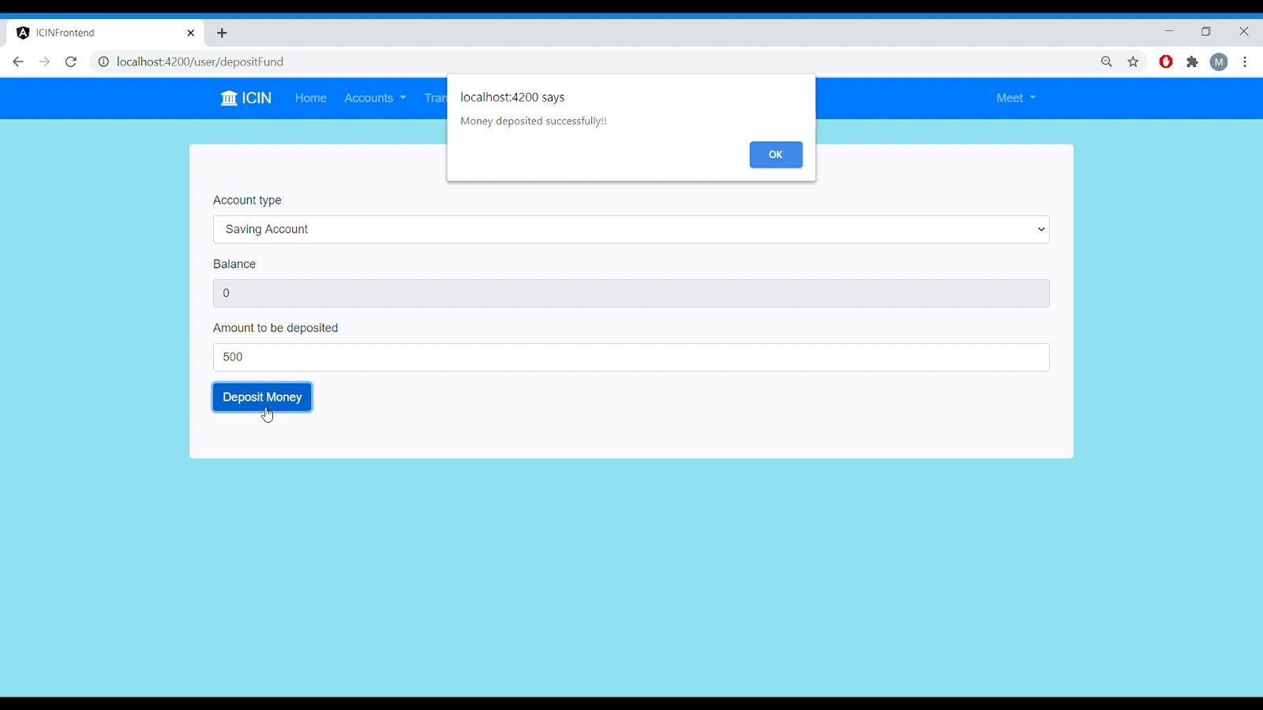

Fig 22. Money Deposited In Saving Account

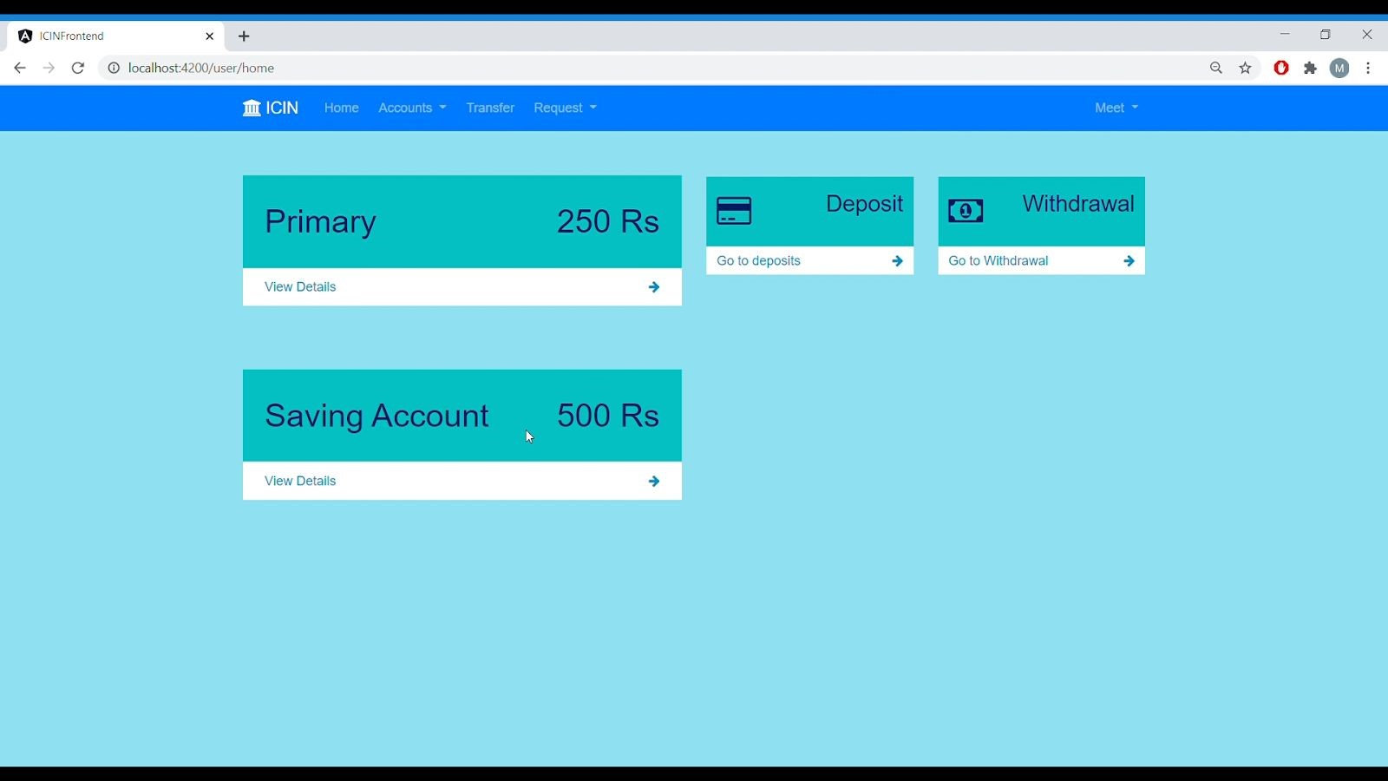

Fig 23. Saving account balance updated

# 5.) Withdraw Fund Page

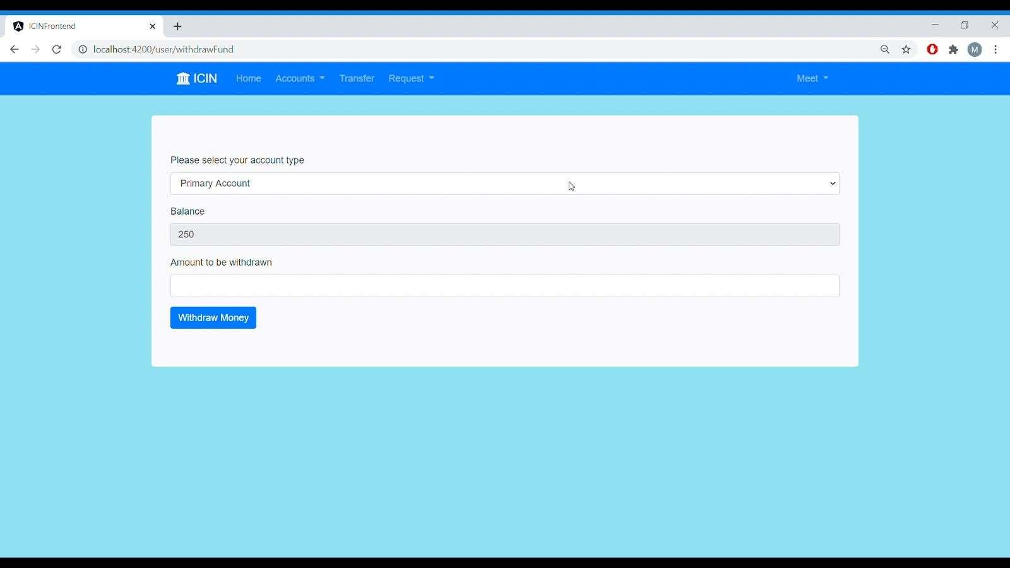

Fig 24. Withdraw Fund Form

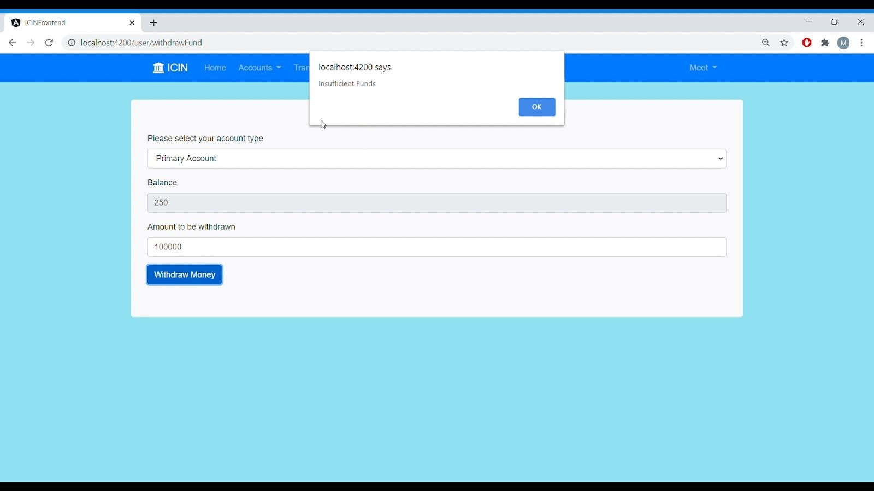

## Fig. 25 When fund requested for withdrawal is greater than available balance

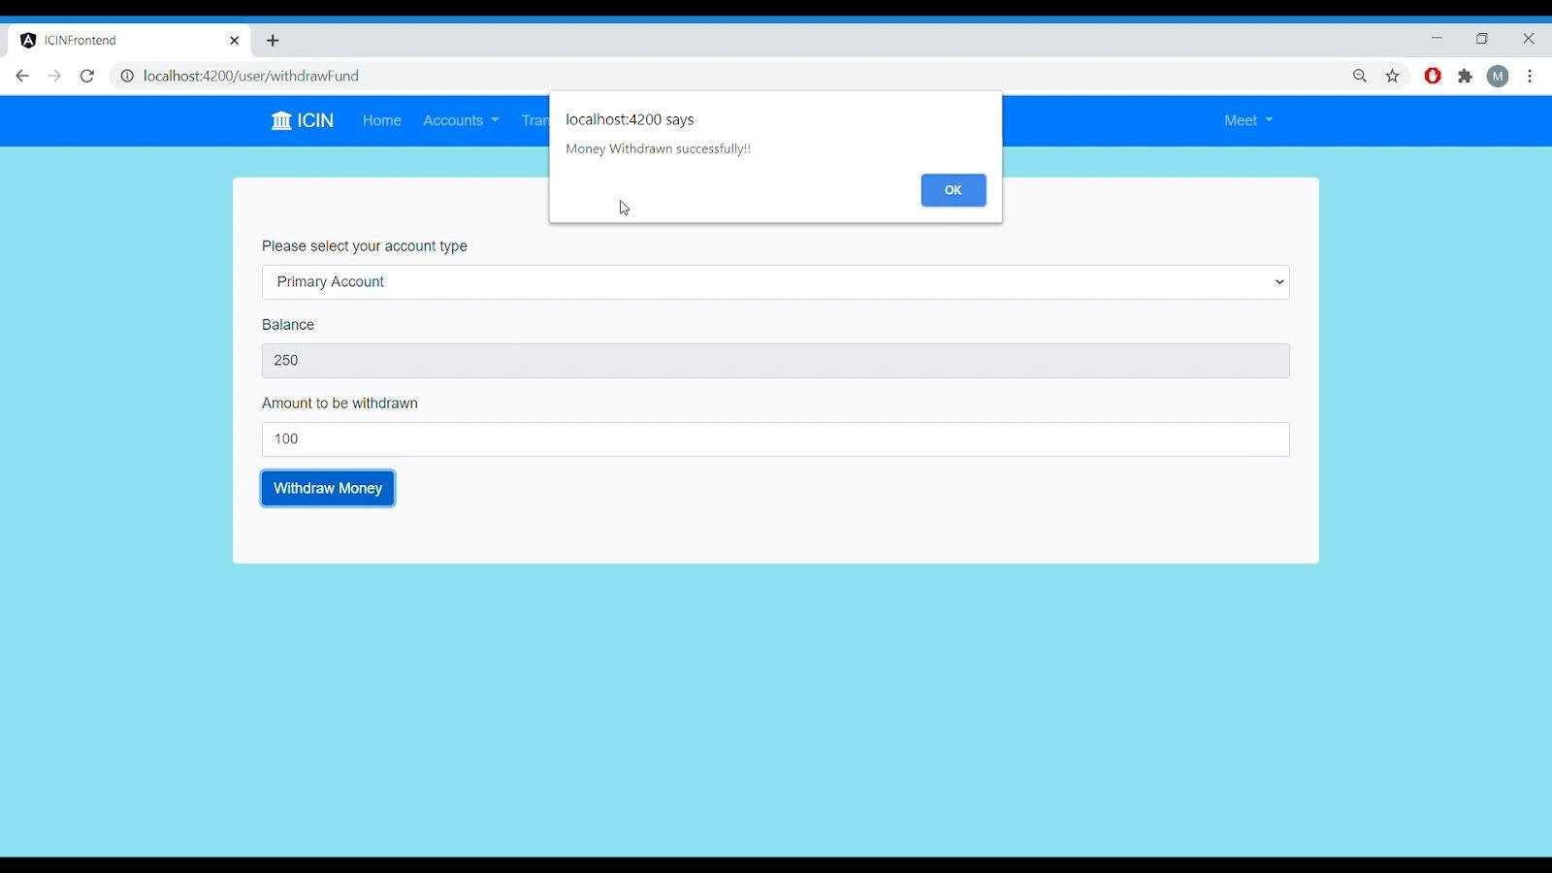

## Fig 26. Successful Money Withdrawal

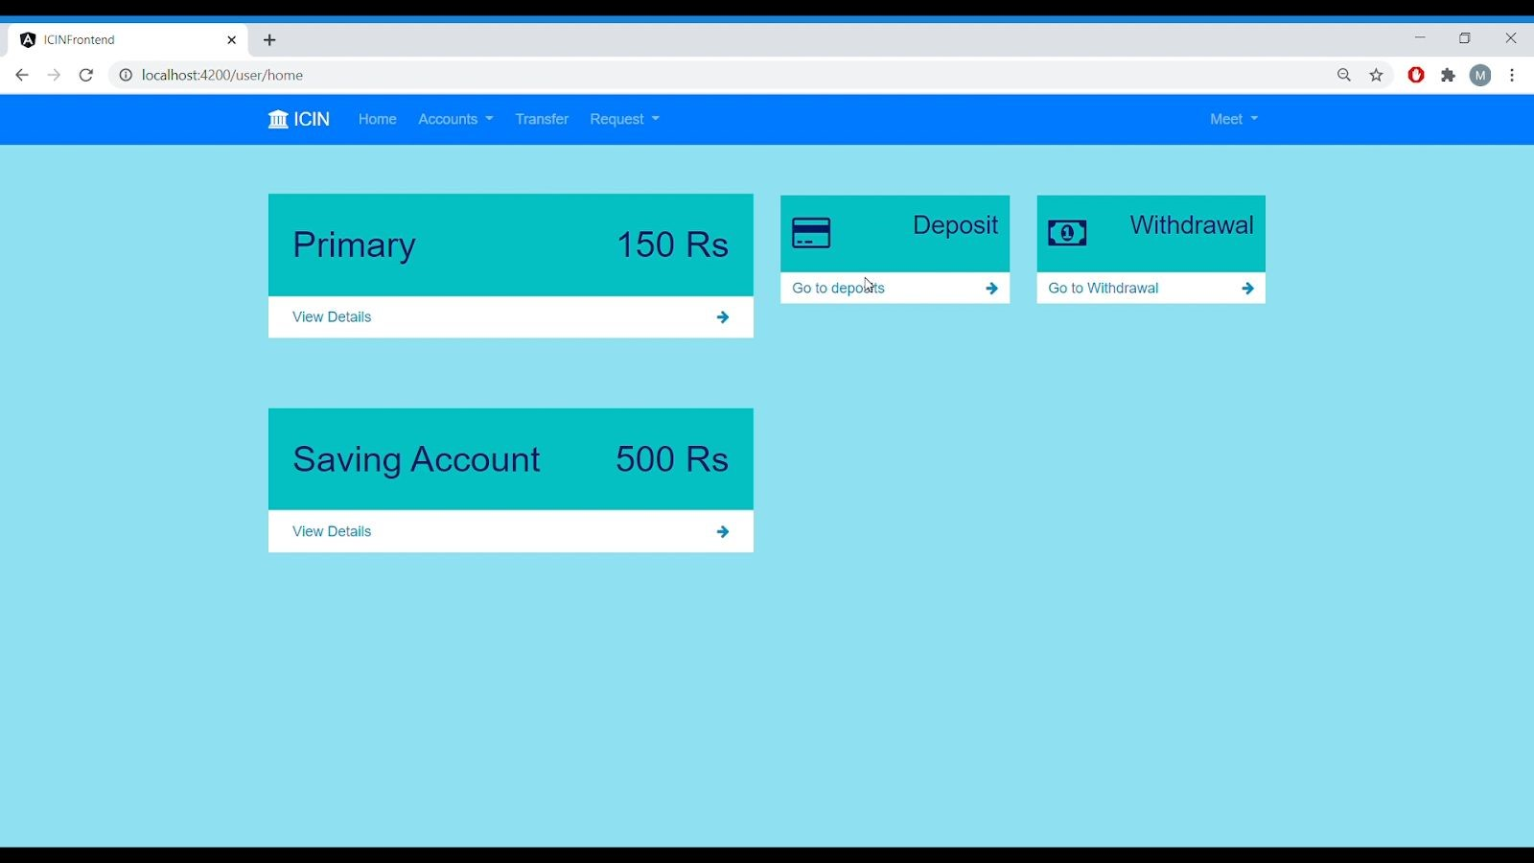

## Fig 27. Balance Updated

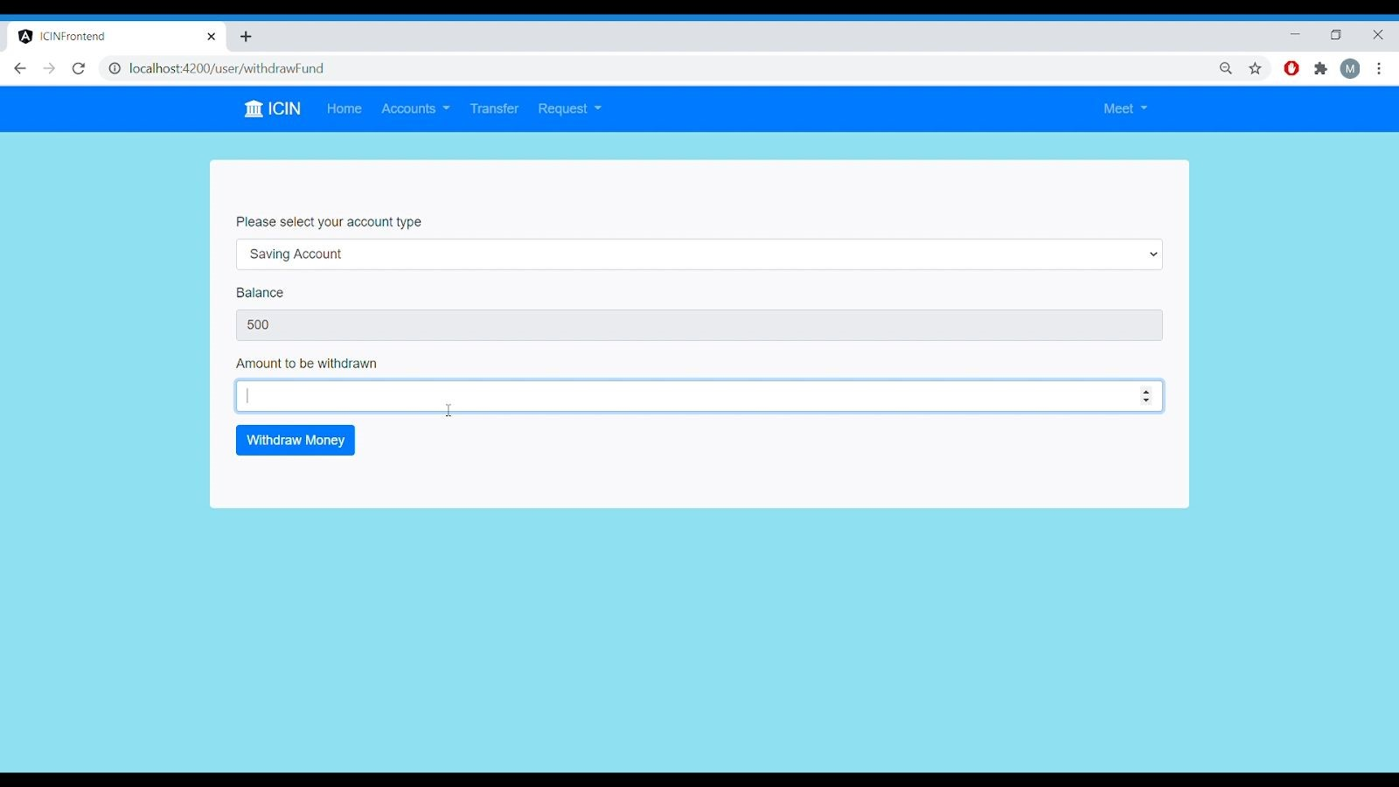

## Fig 28. Fund withdrawal from savings account

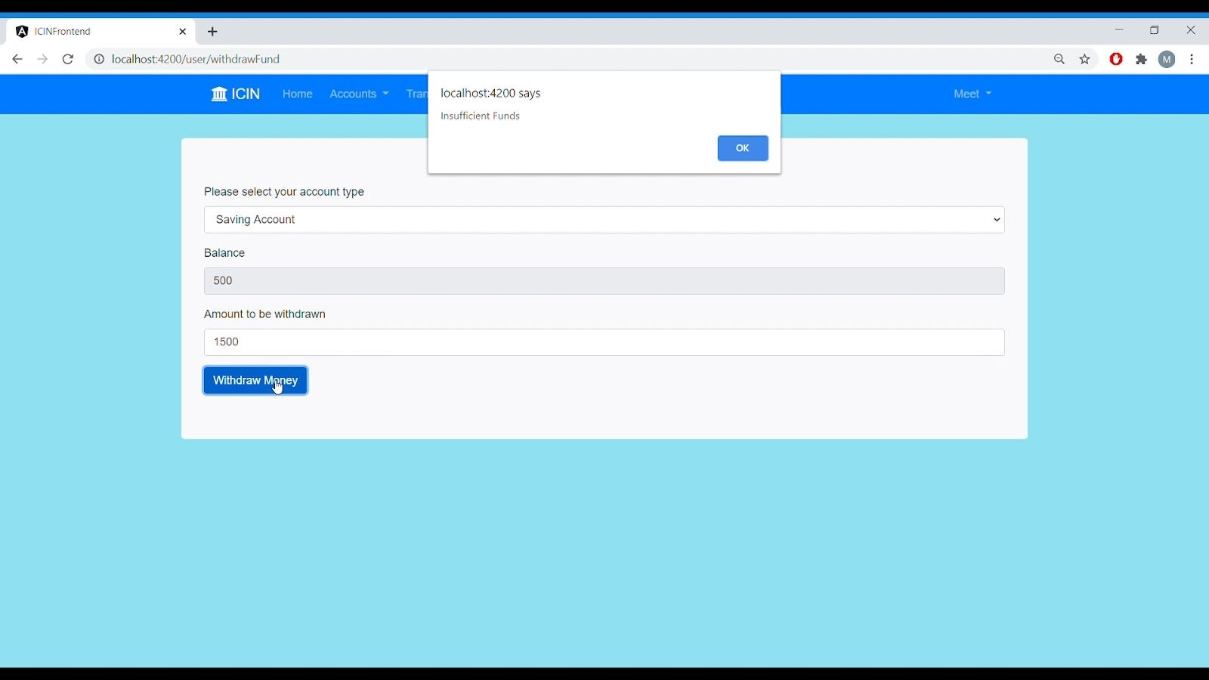

## Fig. 29 When fund requested for withdrawal is greater than available balance

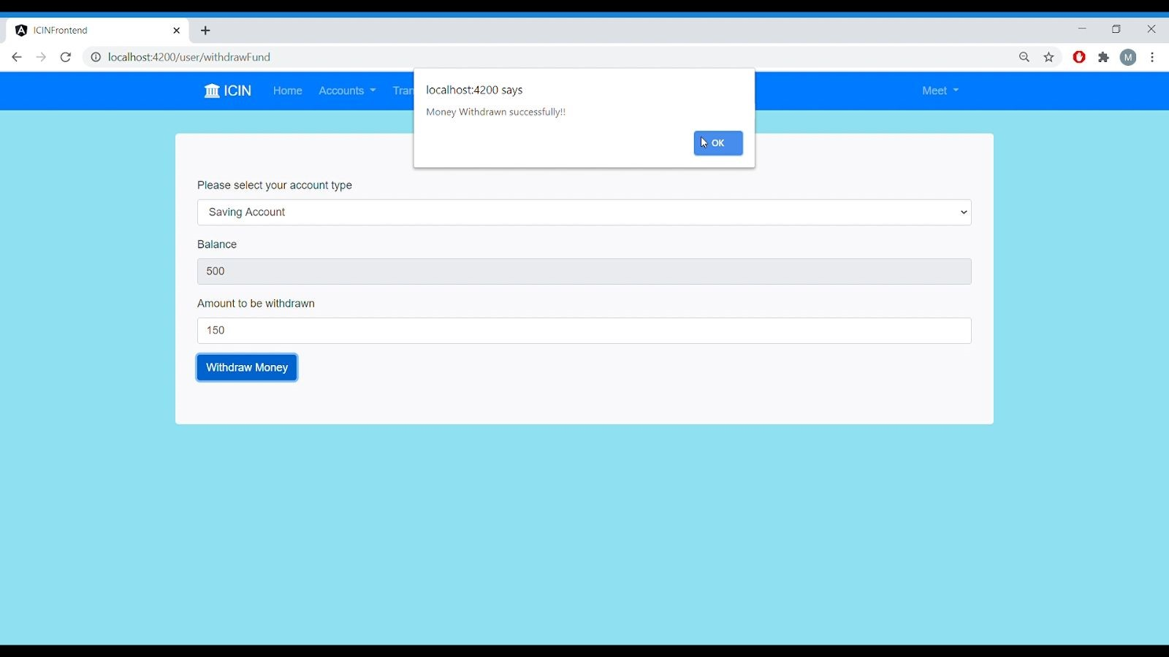

Fig 26. Successful Money Withdrawal from Saving account

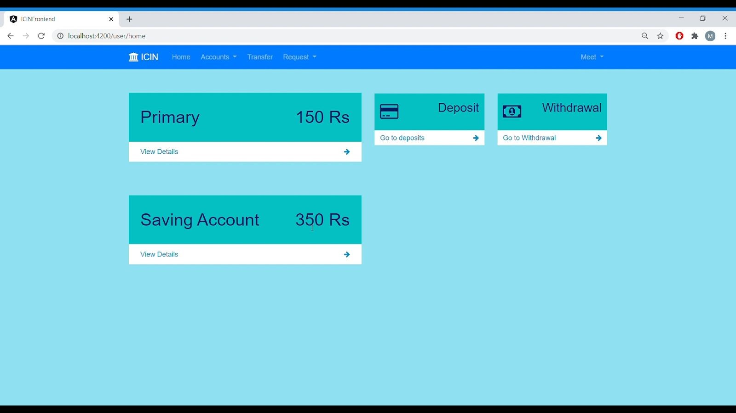

Fig 27. Balance Updated

# 6.) Fund Transfer Page

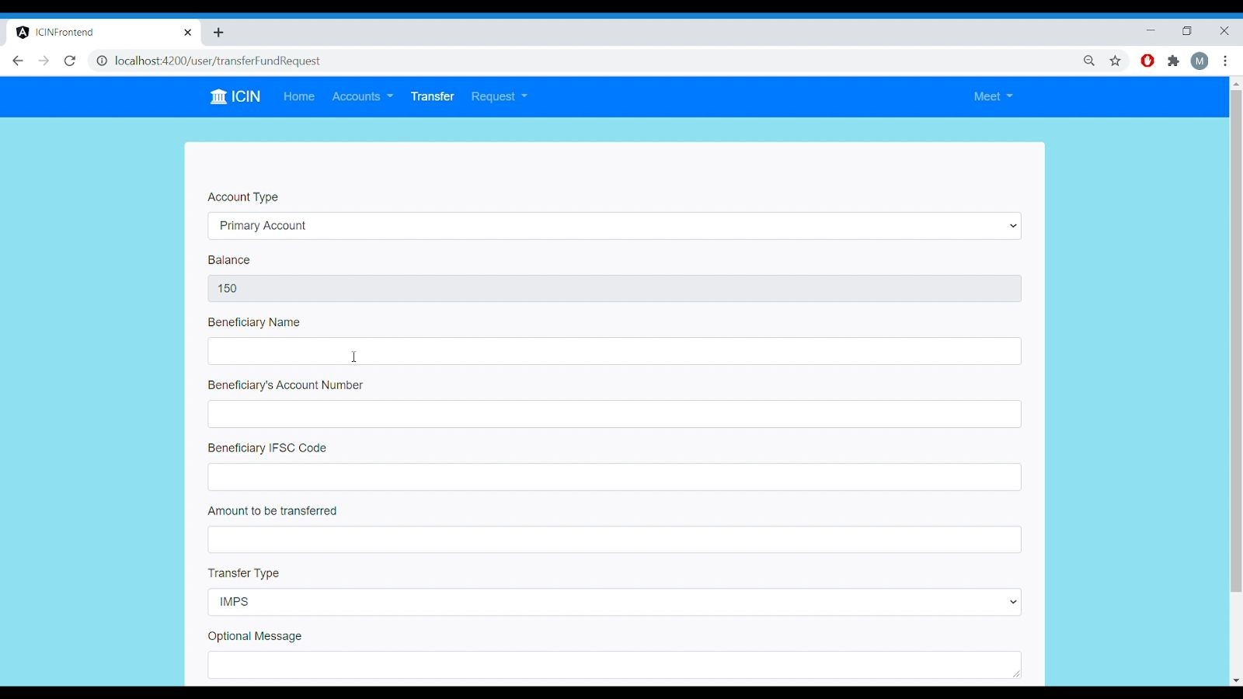

Fig 30. Fund Transfer

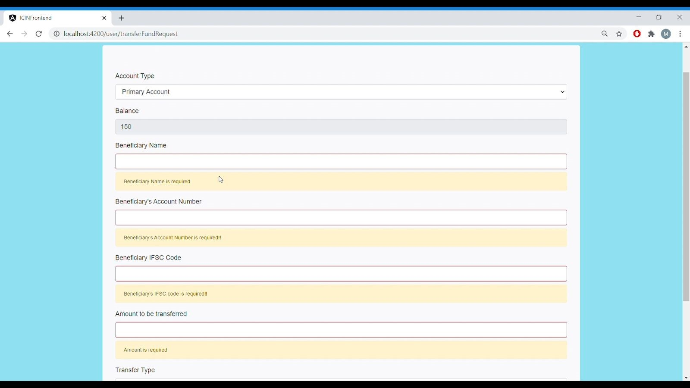

Fig 31. Form Validation

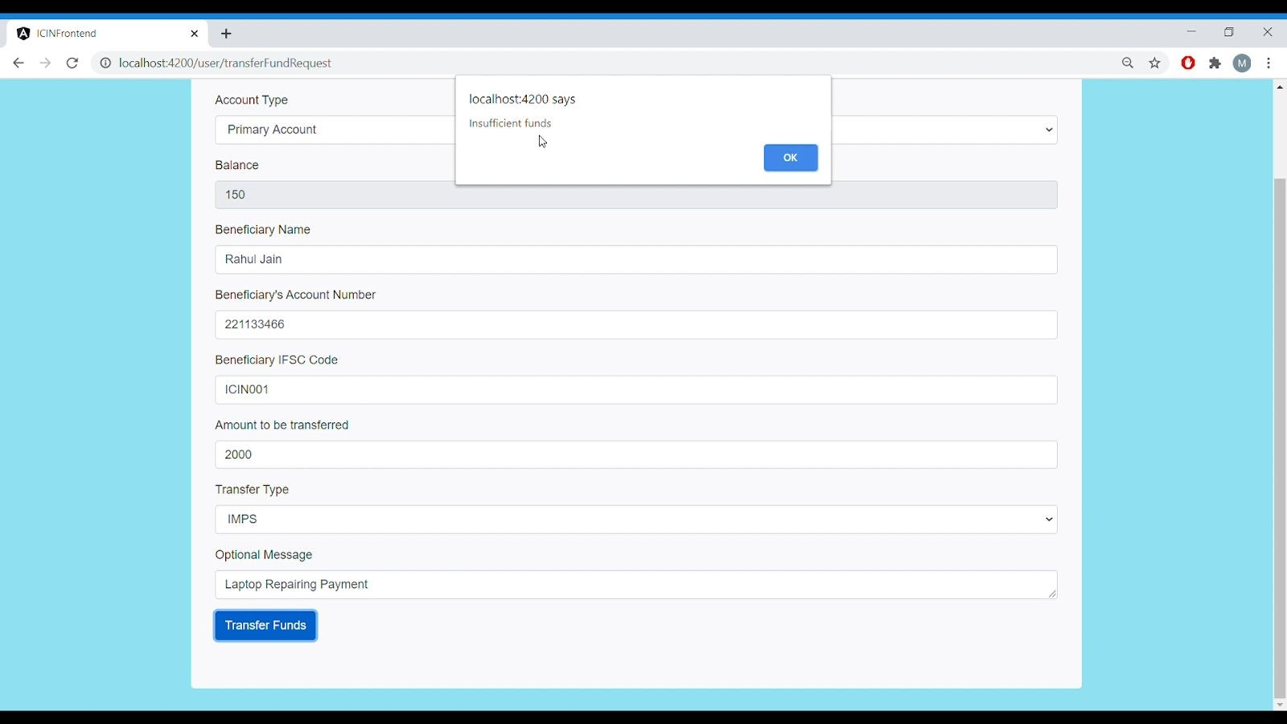

## Fig 32. When amount requested for transfer is greater than current balance

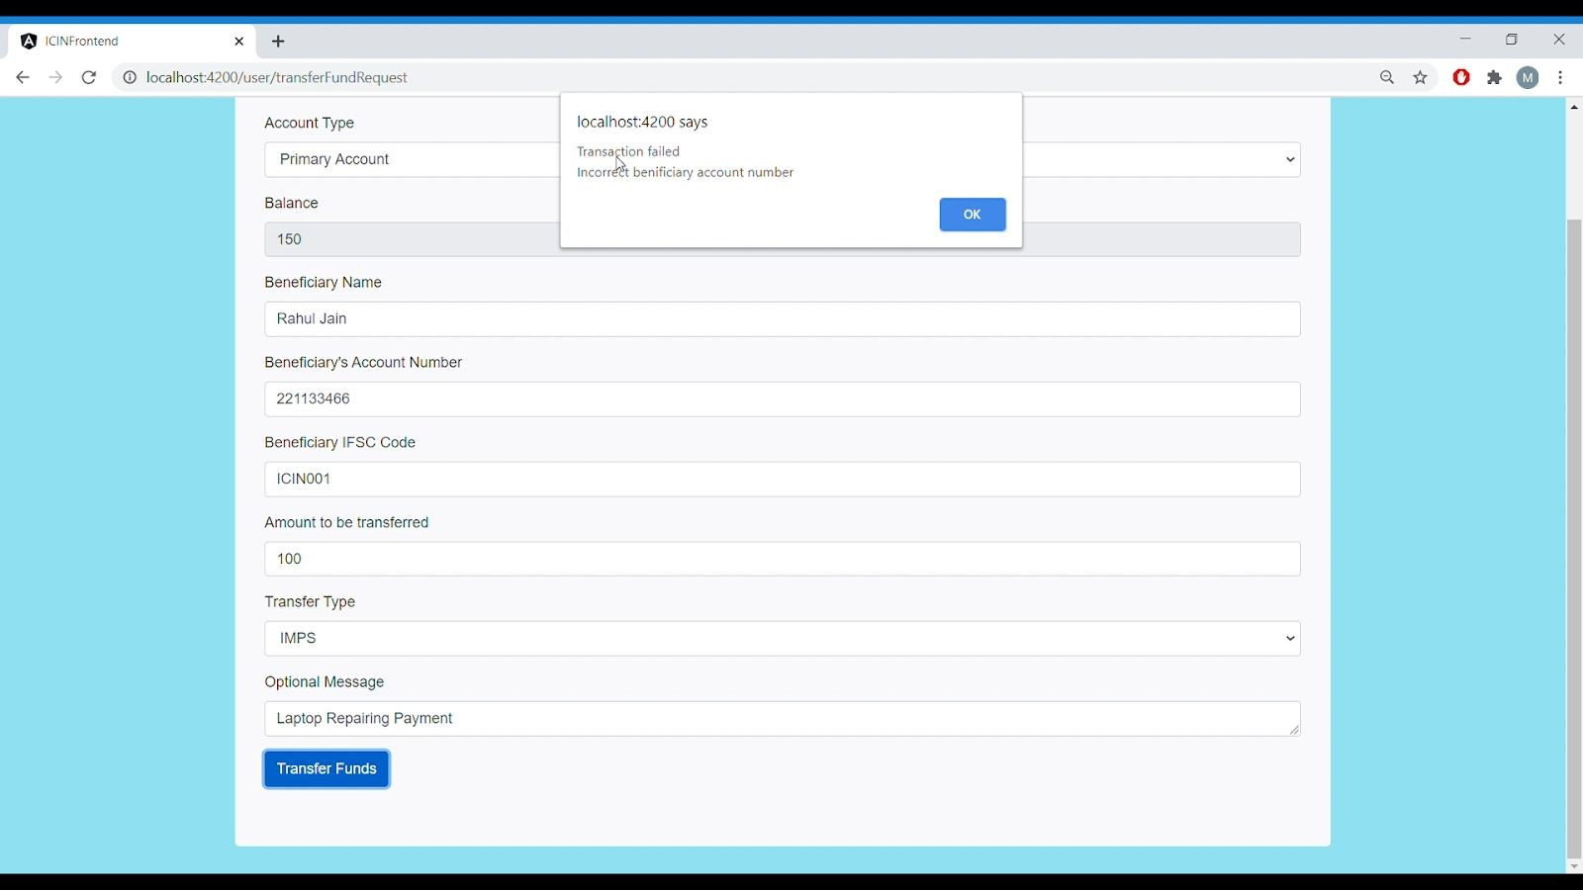

## Fig 33. When beneficiary’s account number is incorrect

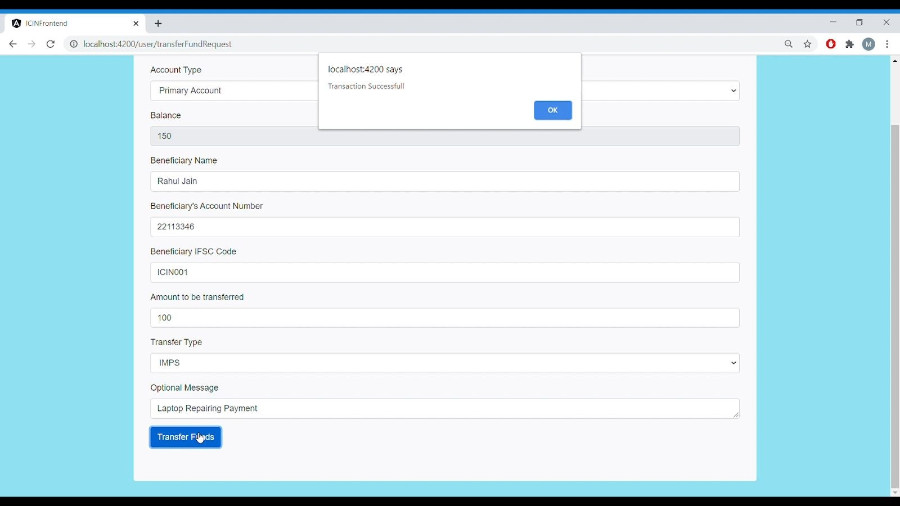

Fig 34. Successful Fund Transfer

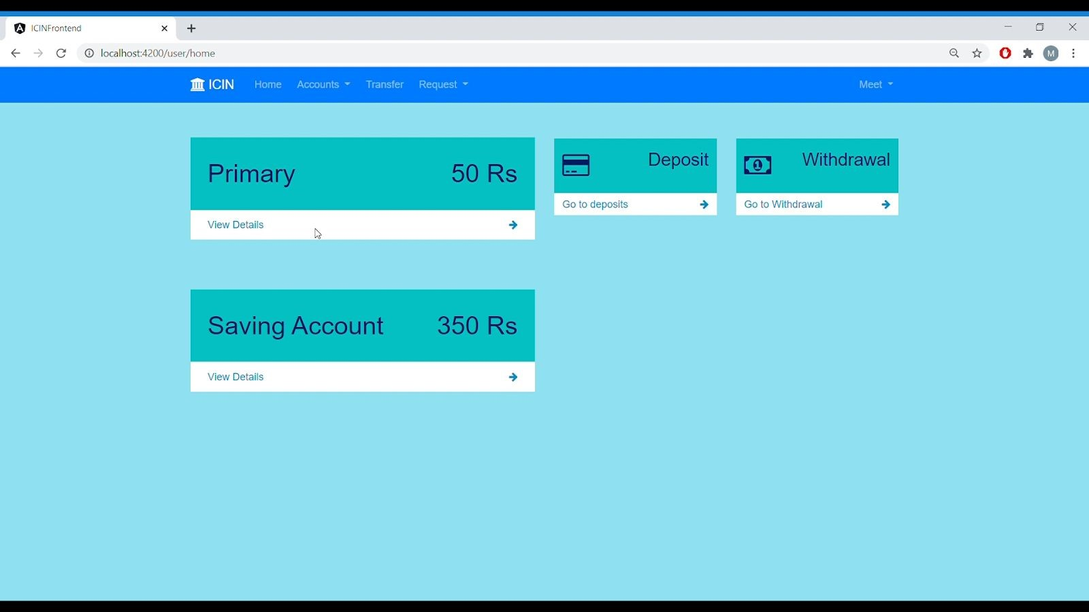

Fig 35. Updated balance

# 7.) Primay Account Page

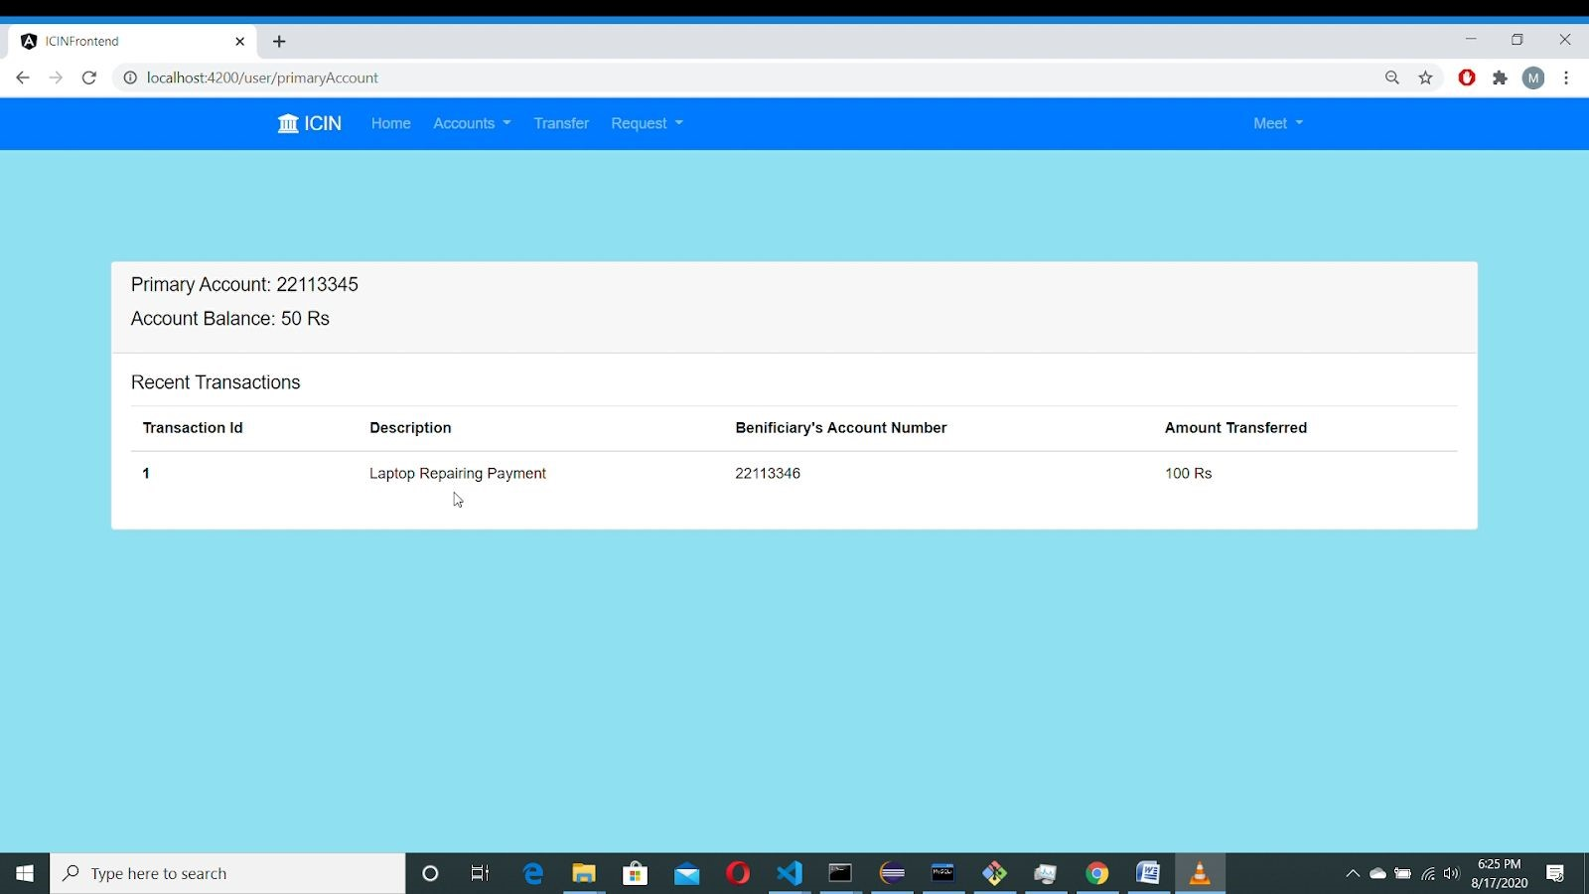

Fig 36. Primary Account Page

# 8.) Saving Account Page

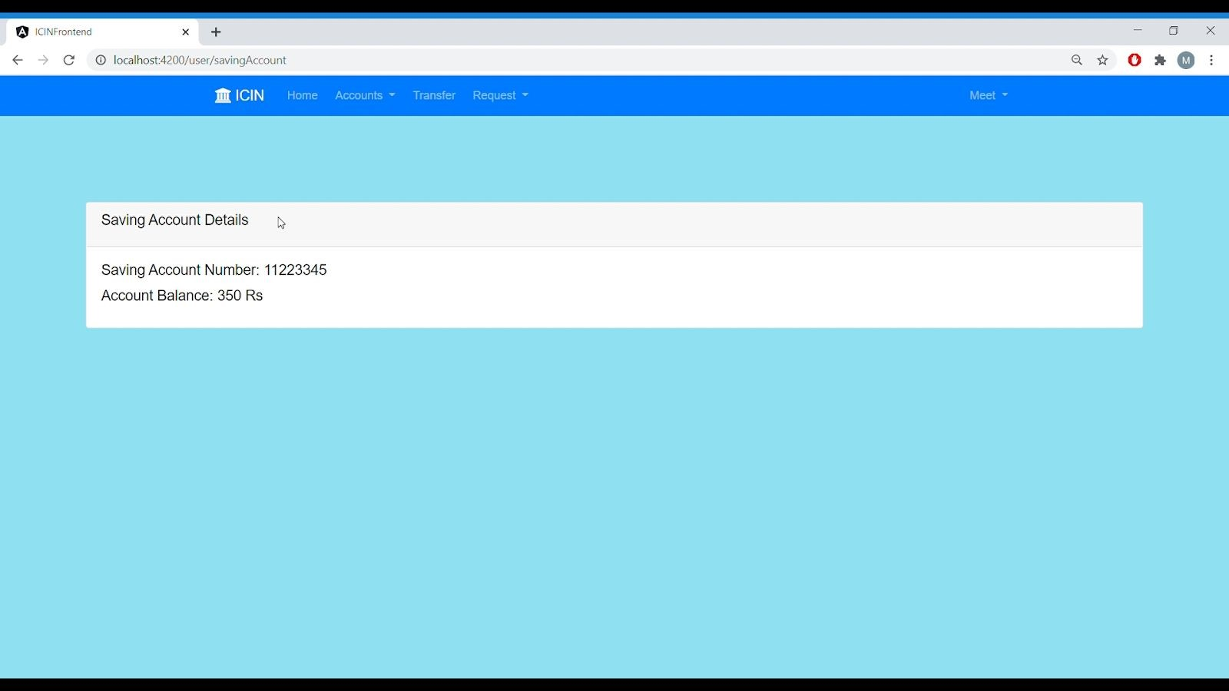

Fig 37. Saving Account Page

# 9.) View Profile Page

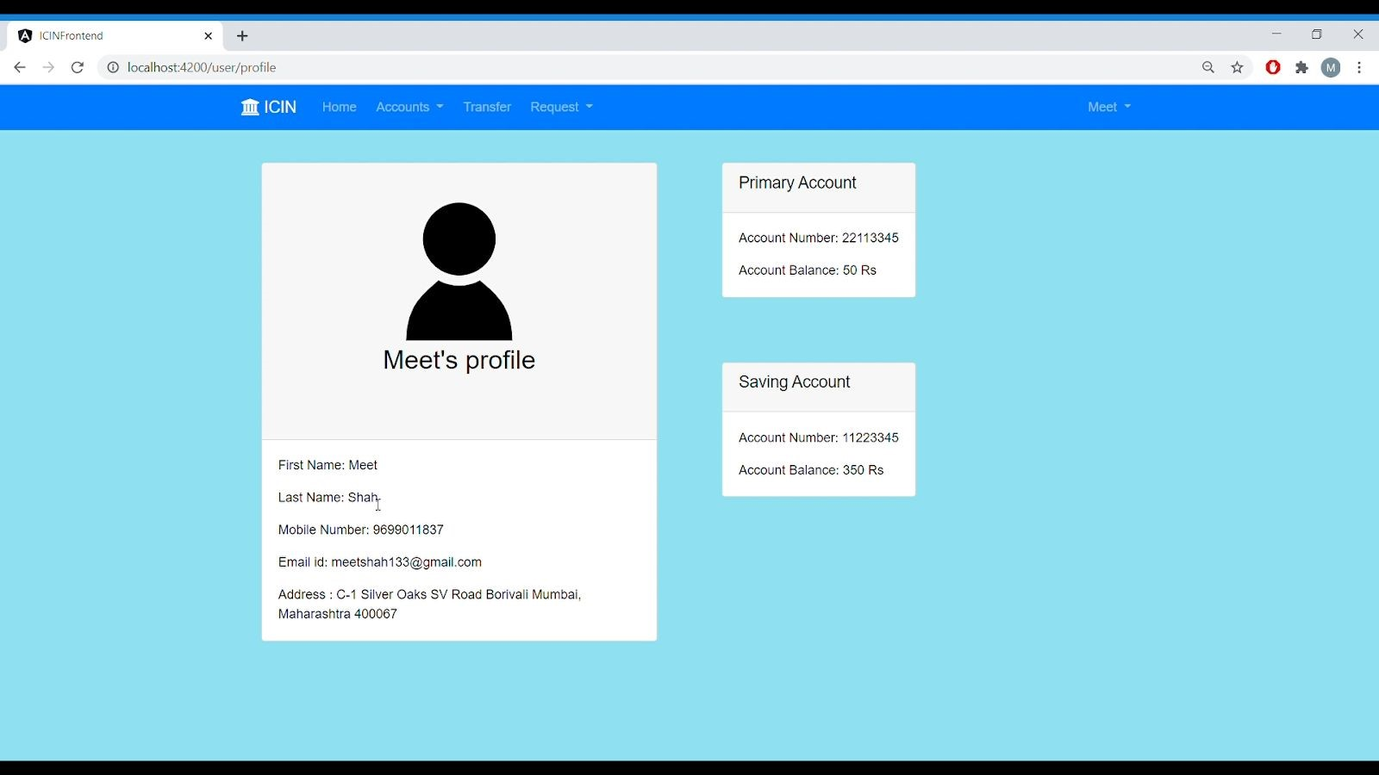

## Fig 38: View Profile Page 10.) Request cheque book section (1.) User Section

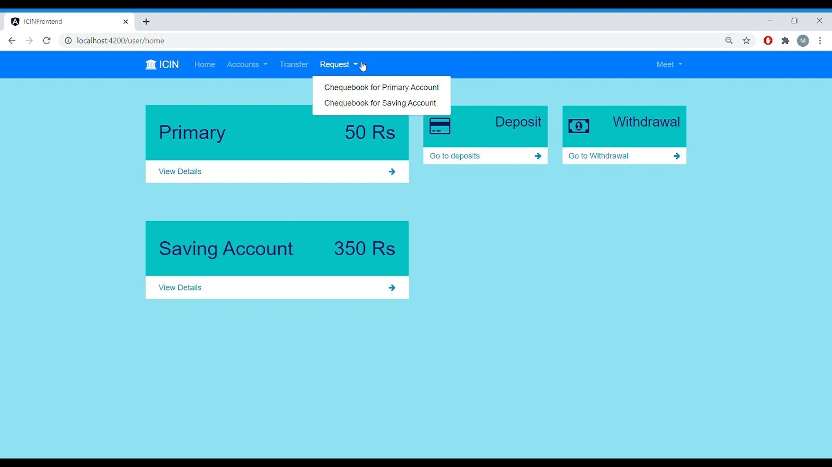

## Fig 39. Selecting request cheque book option

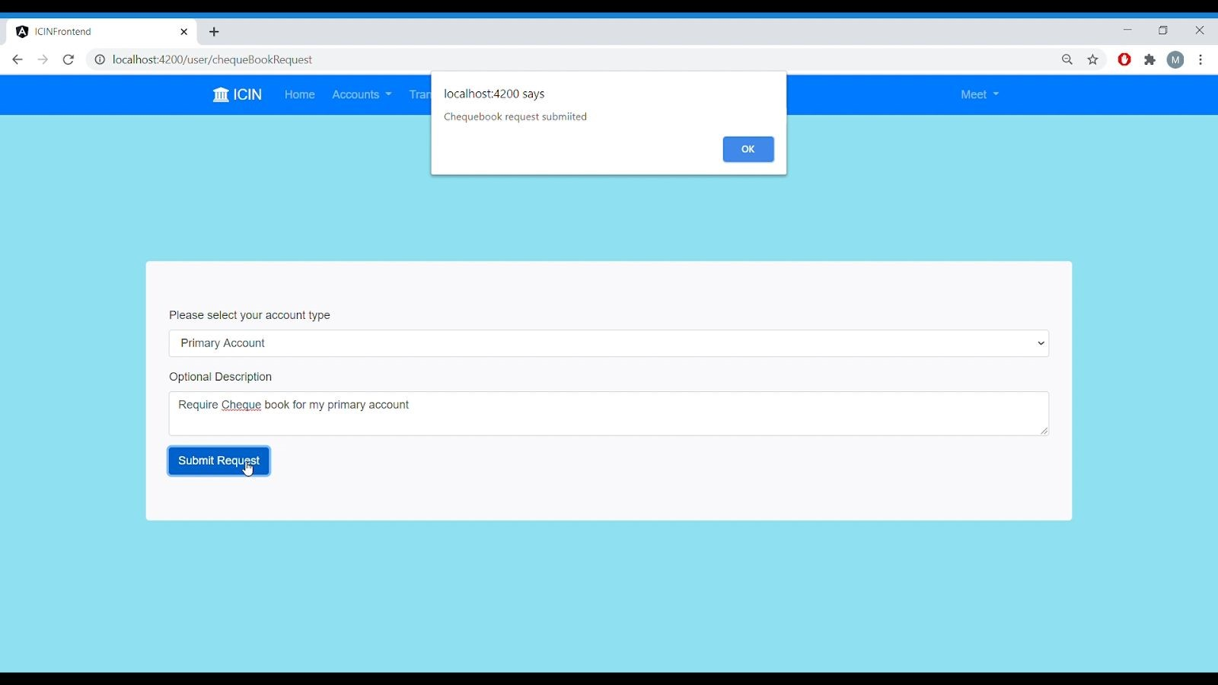

Fig 40. Request Cheque Book form

## (2.) Admin Panel

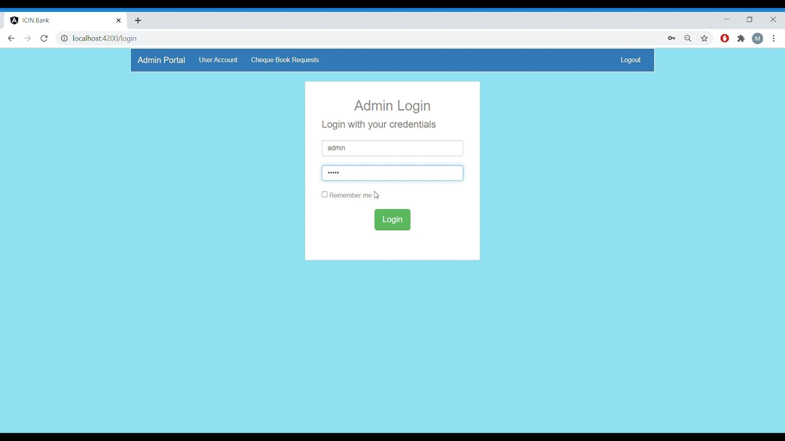

Fig 41: Authentication

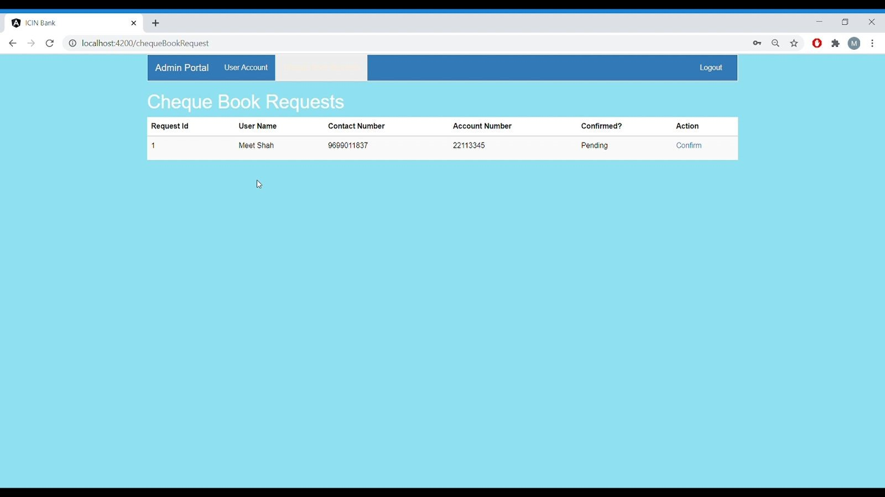

## Fig 42: Viewing available cheque book request

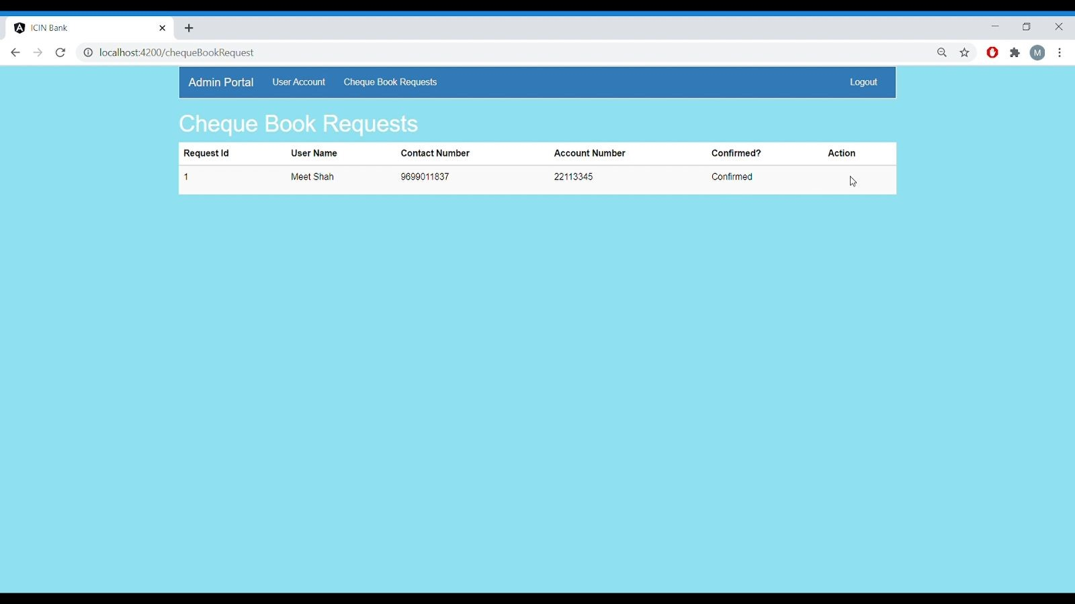

Fig 43: Accepting cheque book request.

## Admin Portal

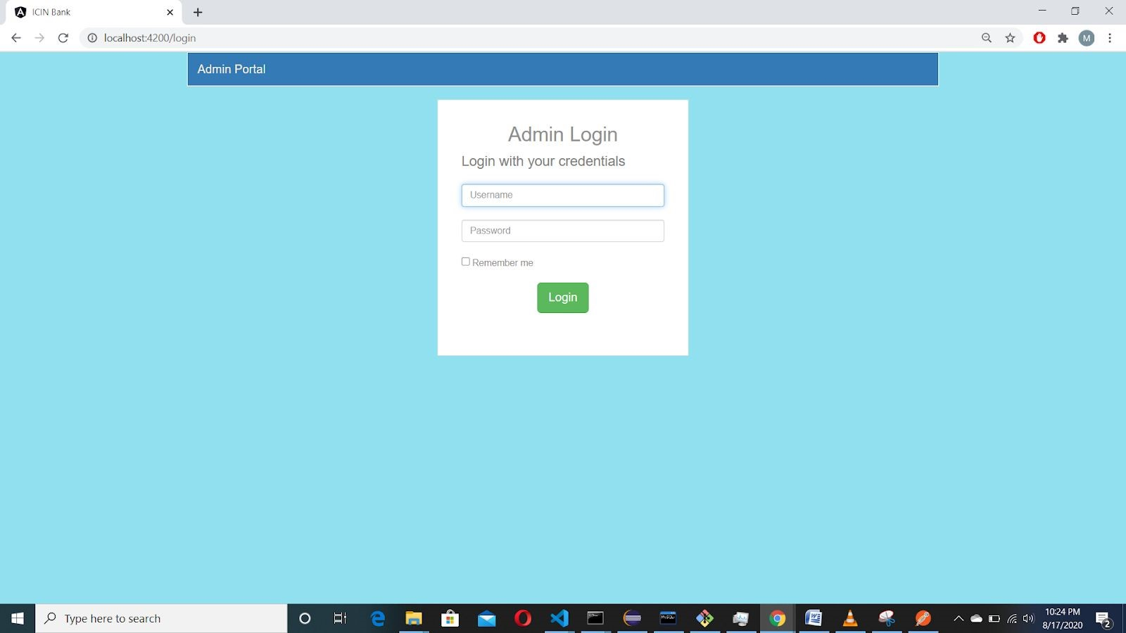

Fig 44: Login Page

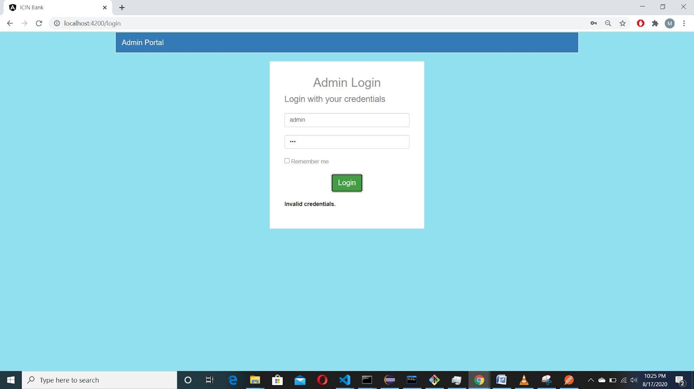

Fig 45: Login Validation

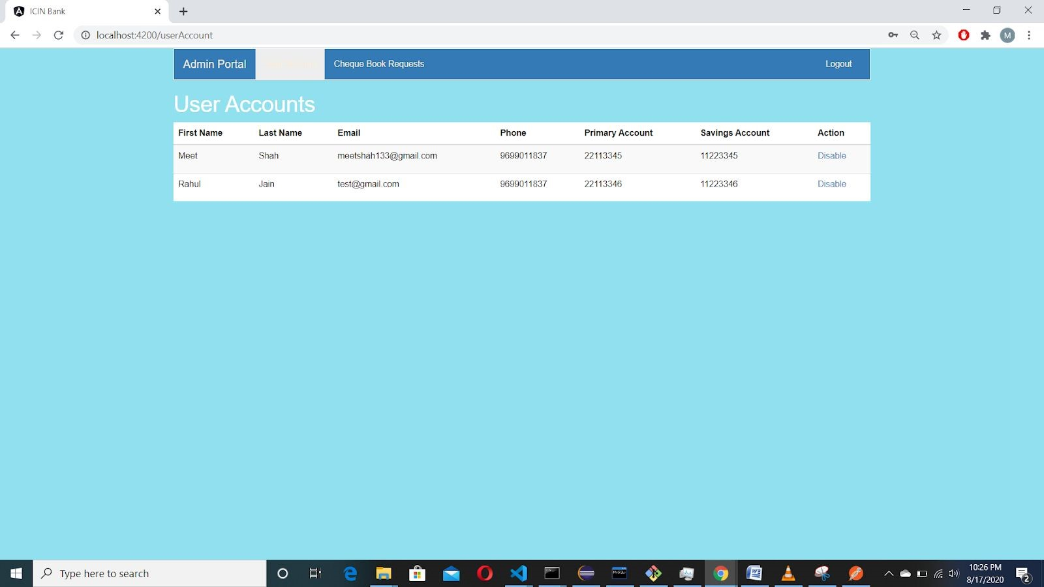

Fig 46: View User’s section

## User’s Portal Screenshots

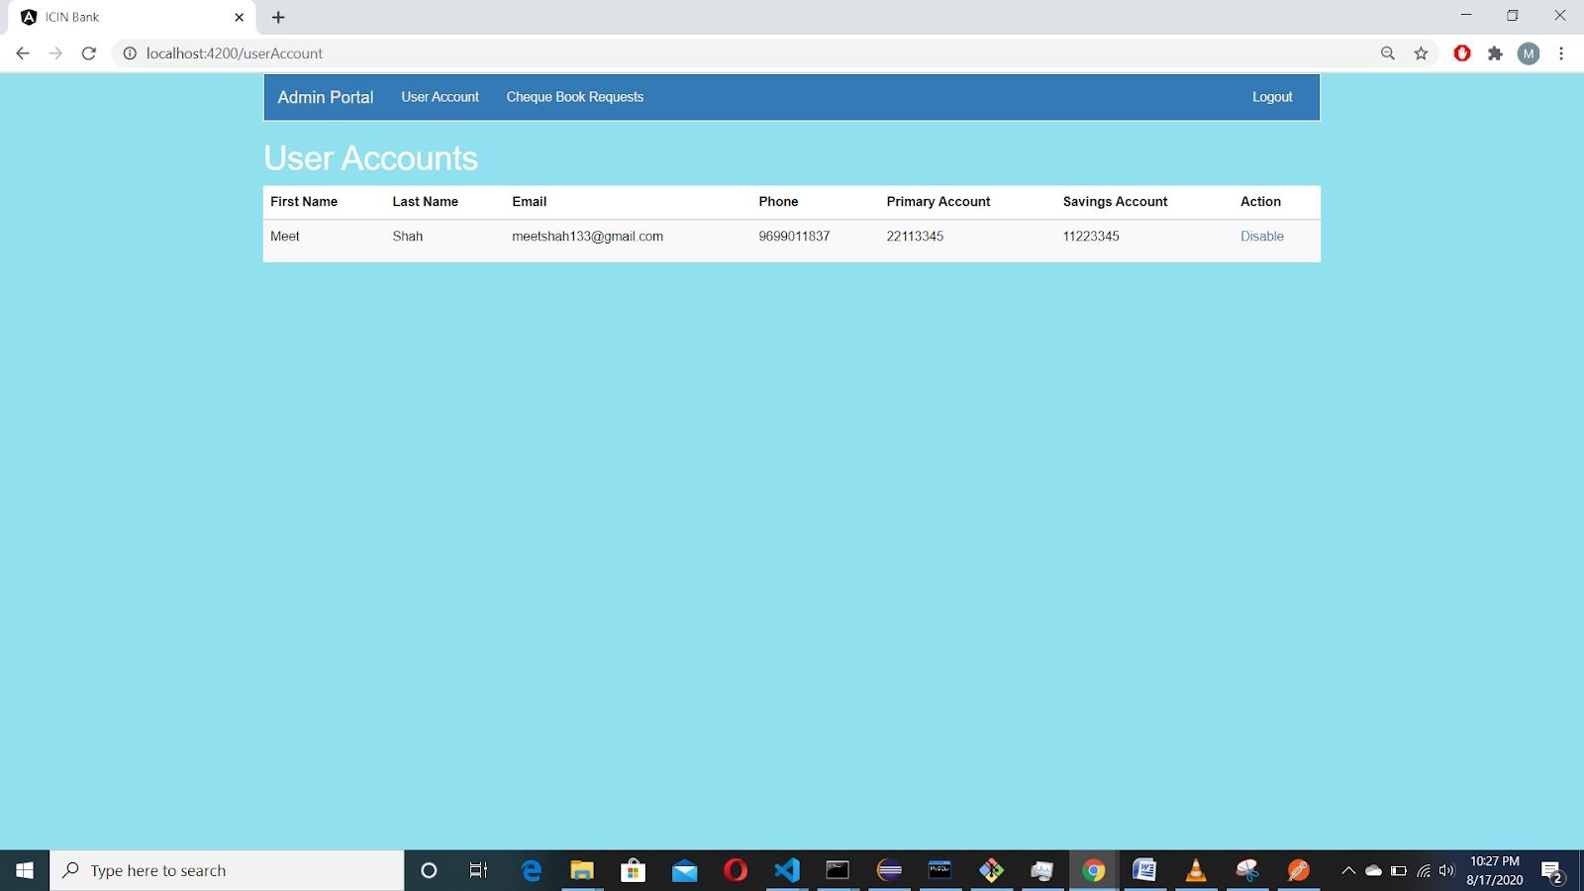

Fig 47: Disabling user through admin portal

Databases:

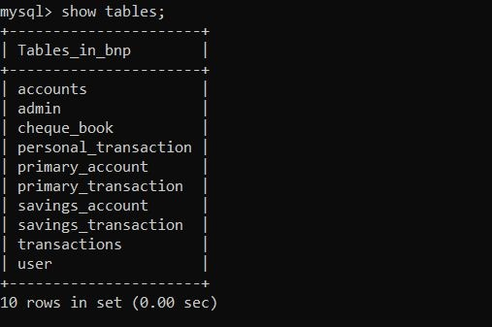

## Fig 48: Tables present in the database

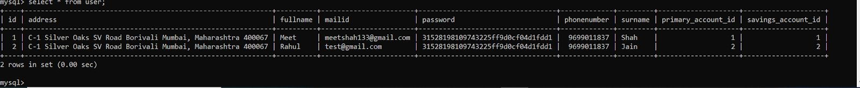

Fig 49: User Table

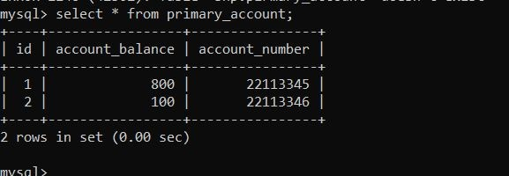

Fig 50: Primary Account Table

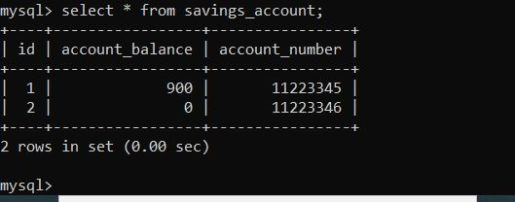

## Fig 51: Saving Account

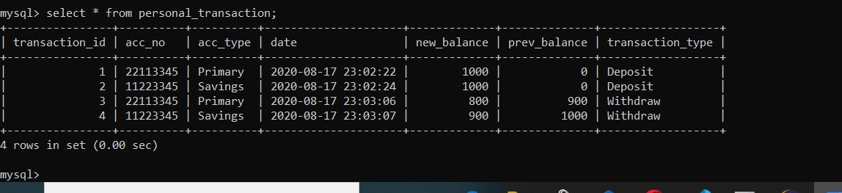

## Fig 52: Personal Transaction

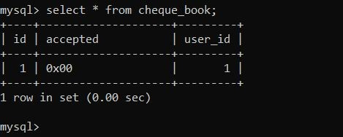

## Fig 53: Cheque Book Request Table

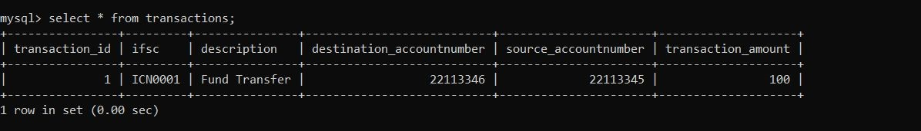

## Fig 54: Transaction table

Testing:

**JUNIT TEST CASES**

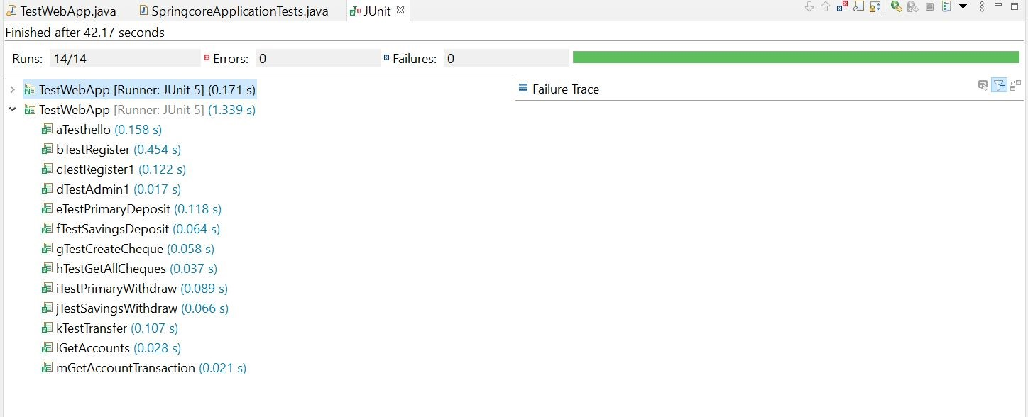

**TEST USER REGISTER**

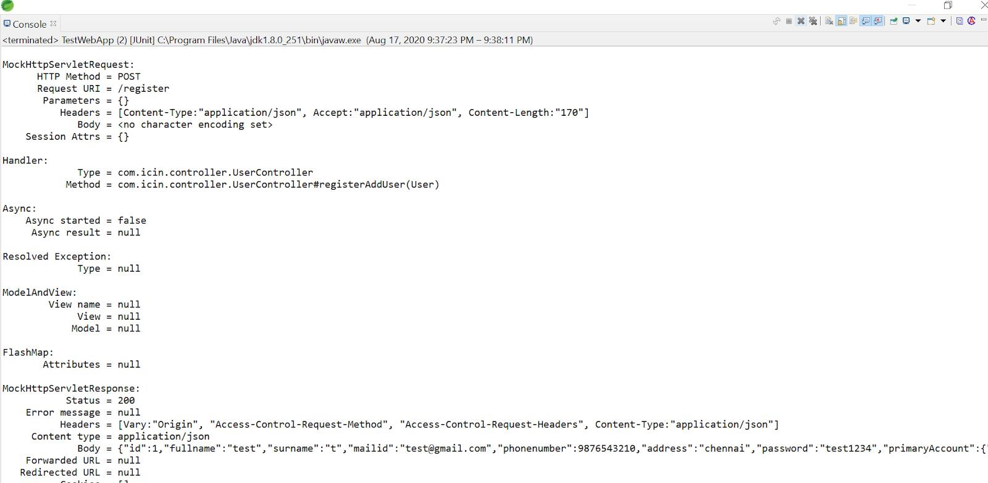

**TEST ADMIN REGISTER**

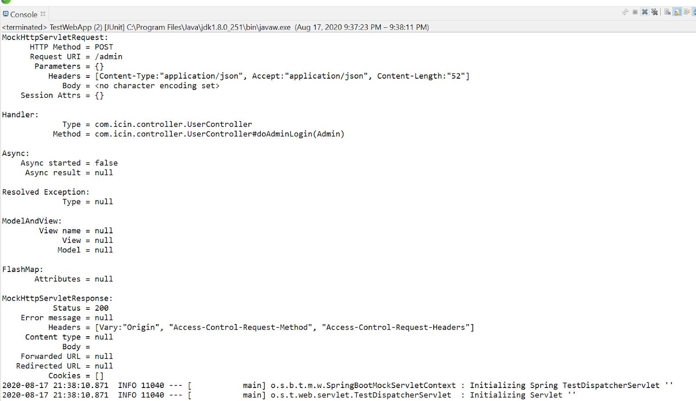

**TEST PRIMARY ACCOUNT DEPOSIT**

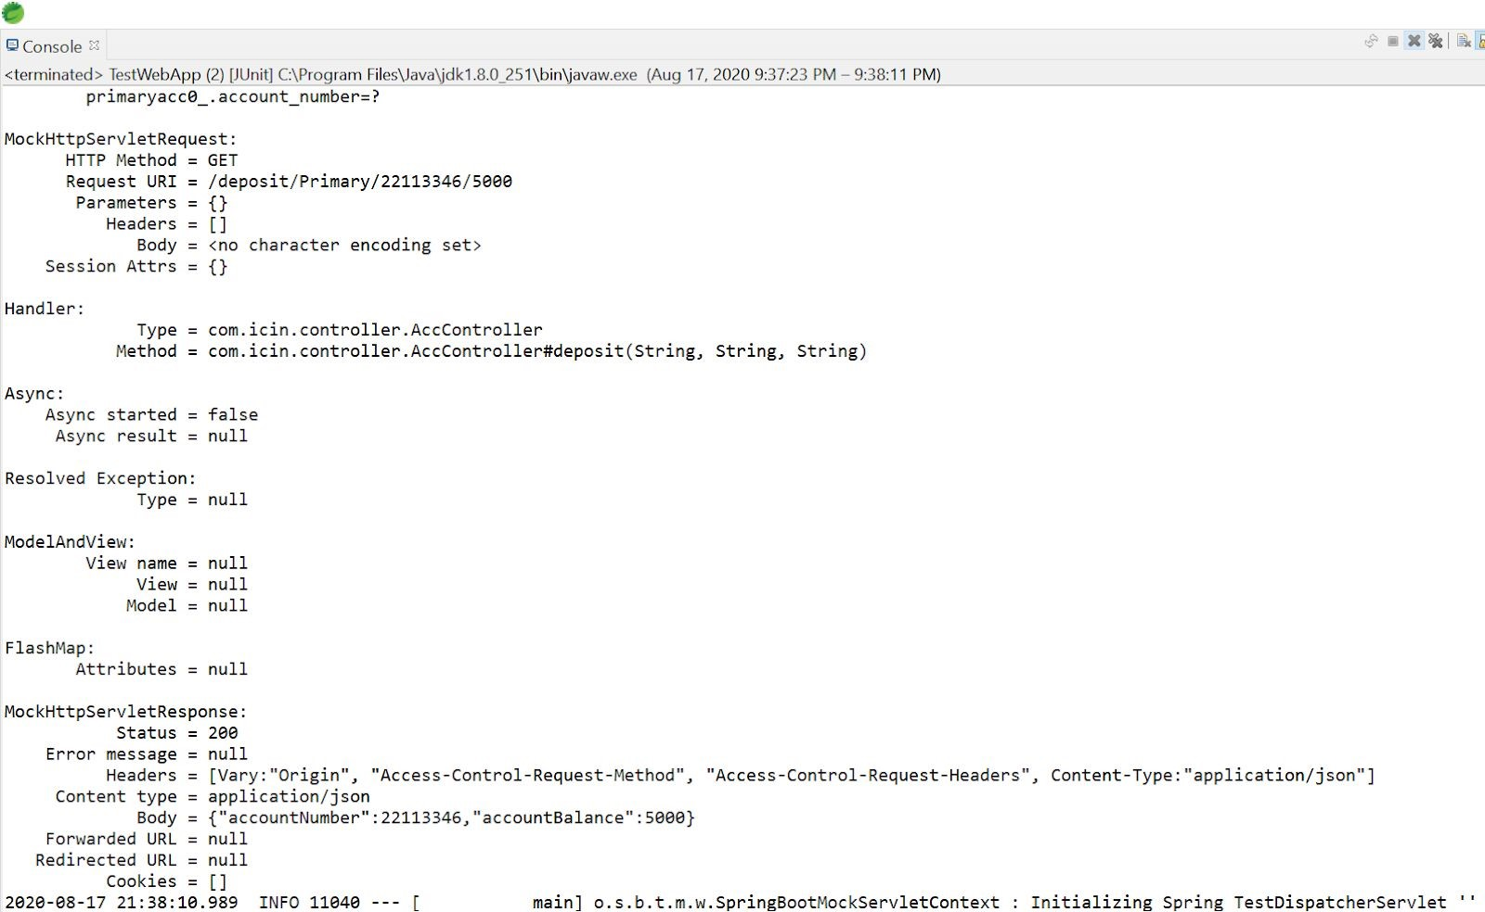

**TEST SAVINGS ACCOUNT DEPOSIT**

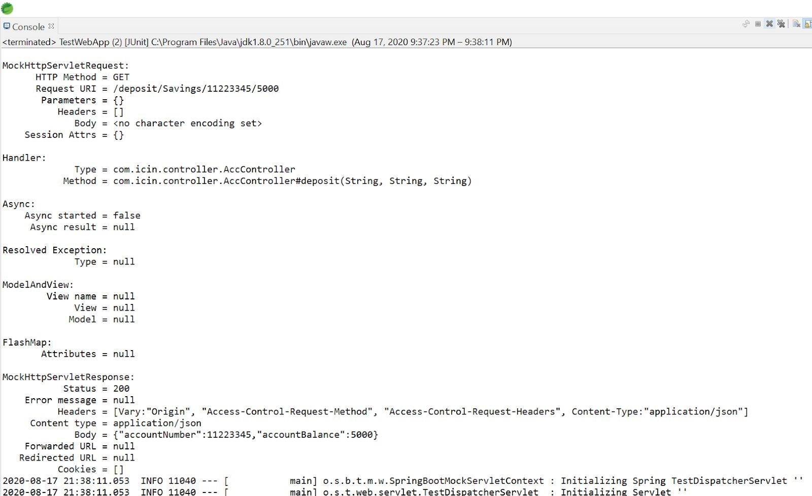

**TEST CREATE CHEQUE**

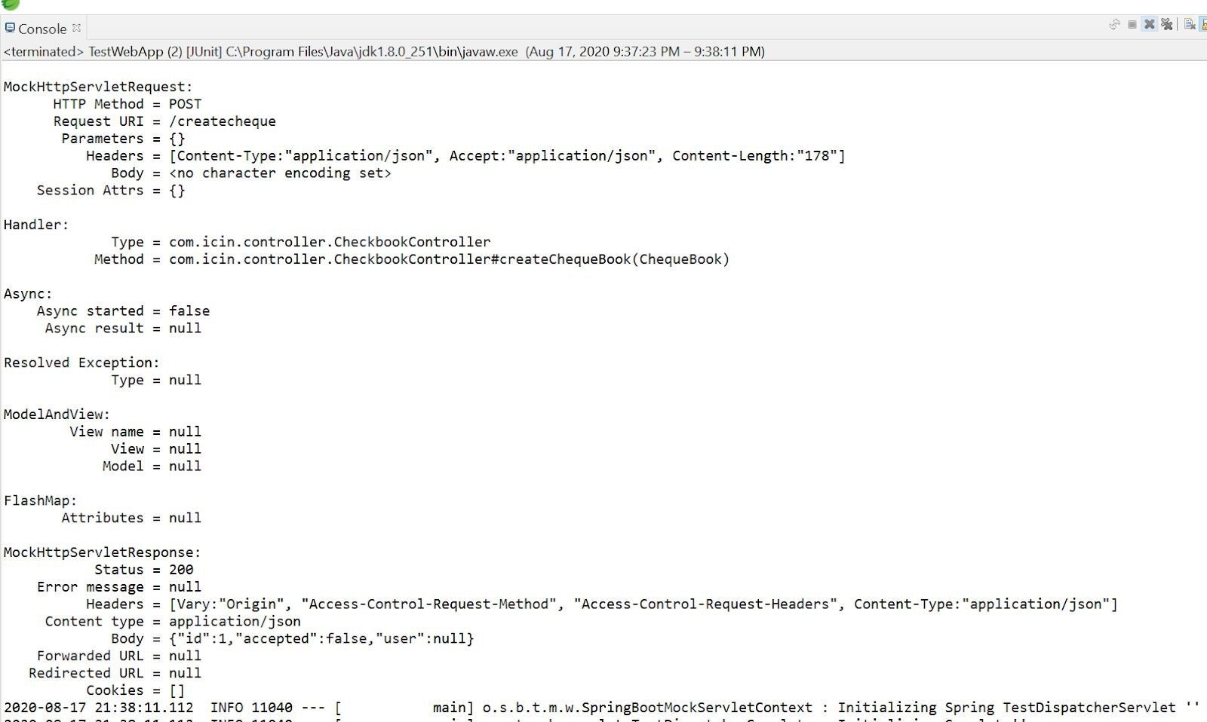

**TEST GETALL CHEQUE**

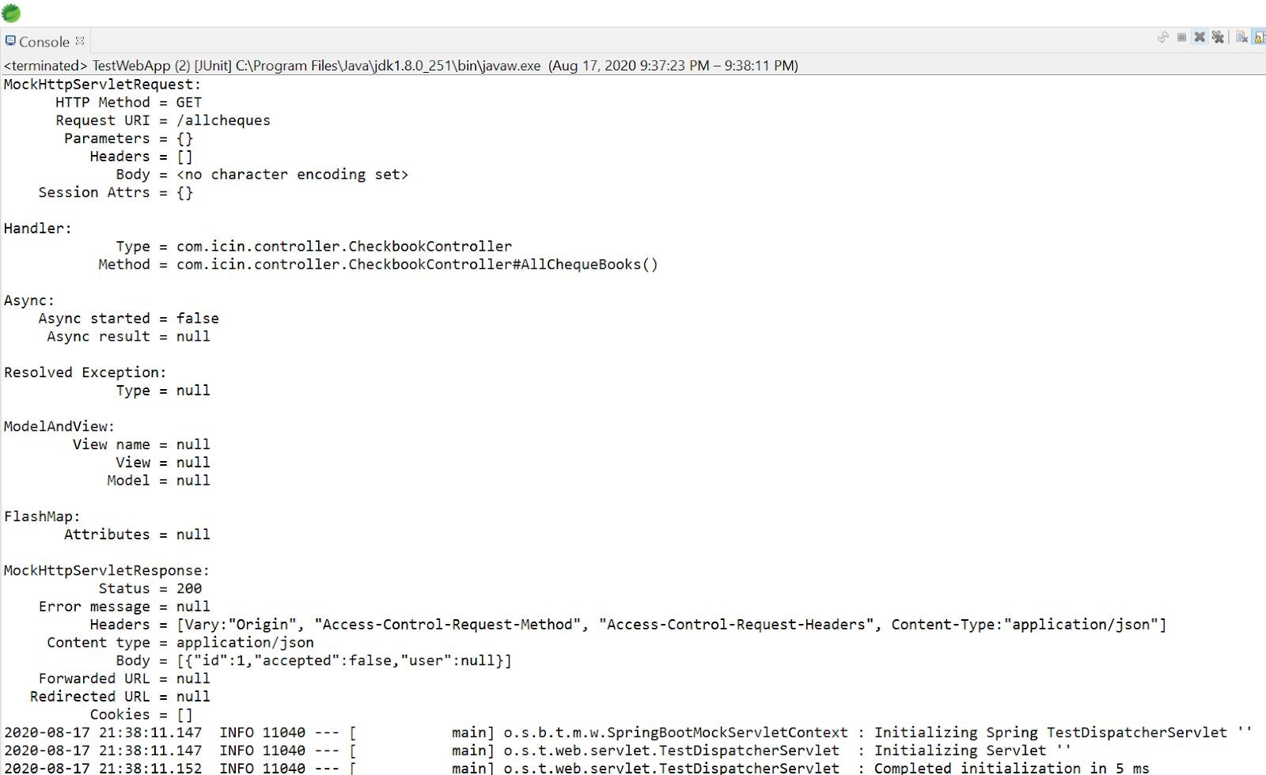

**TEST PRIMARY ACCOUNT WITHDRAW**

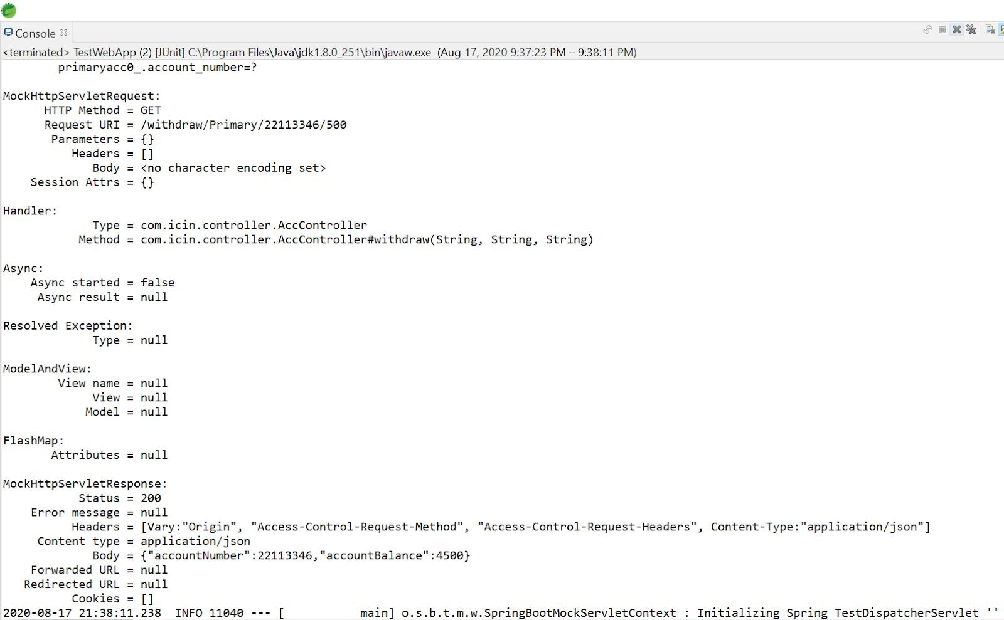

**TEST SAVINGS WITHDRAW**

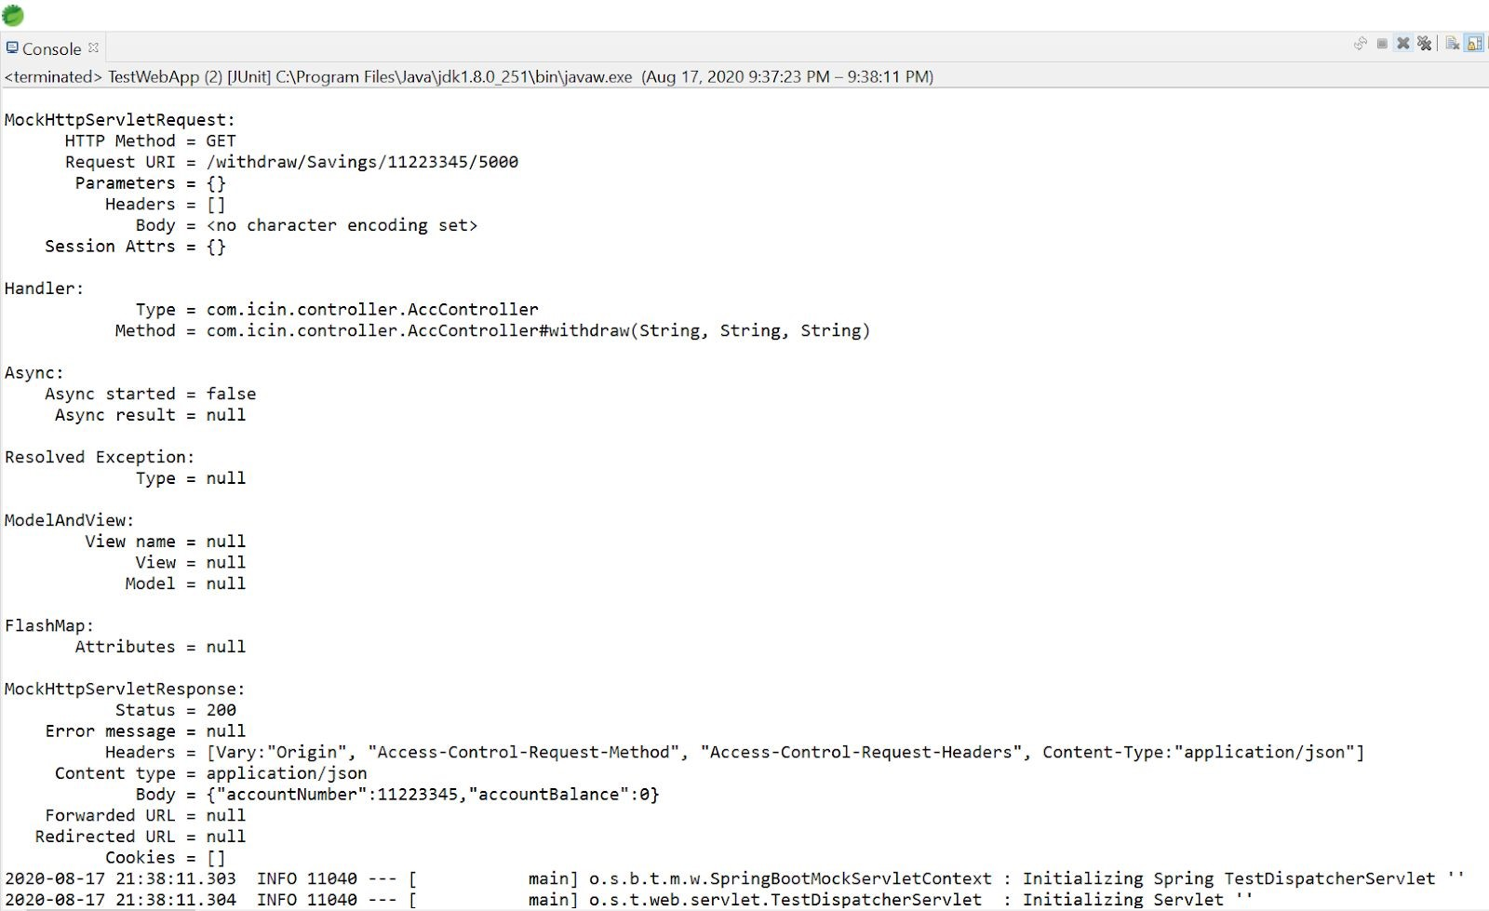

**TEST TRANSFER**

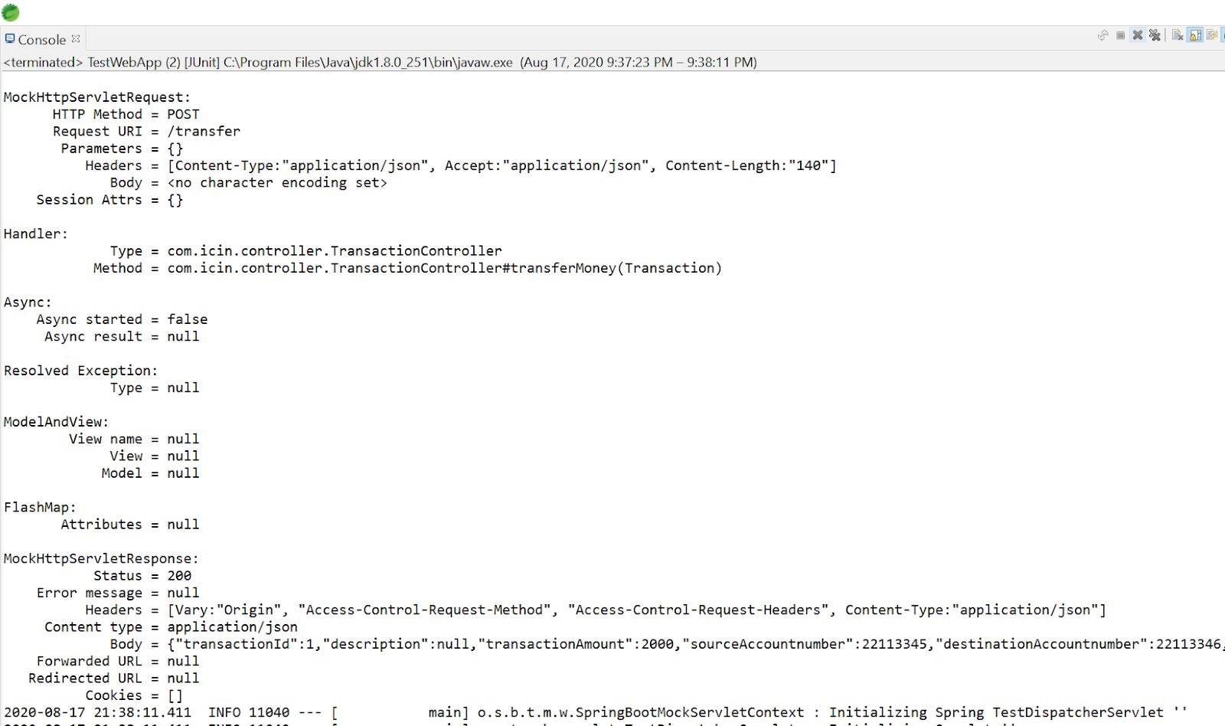

**TEST GET ALL ACCOUNTS**

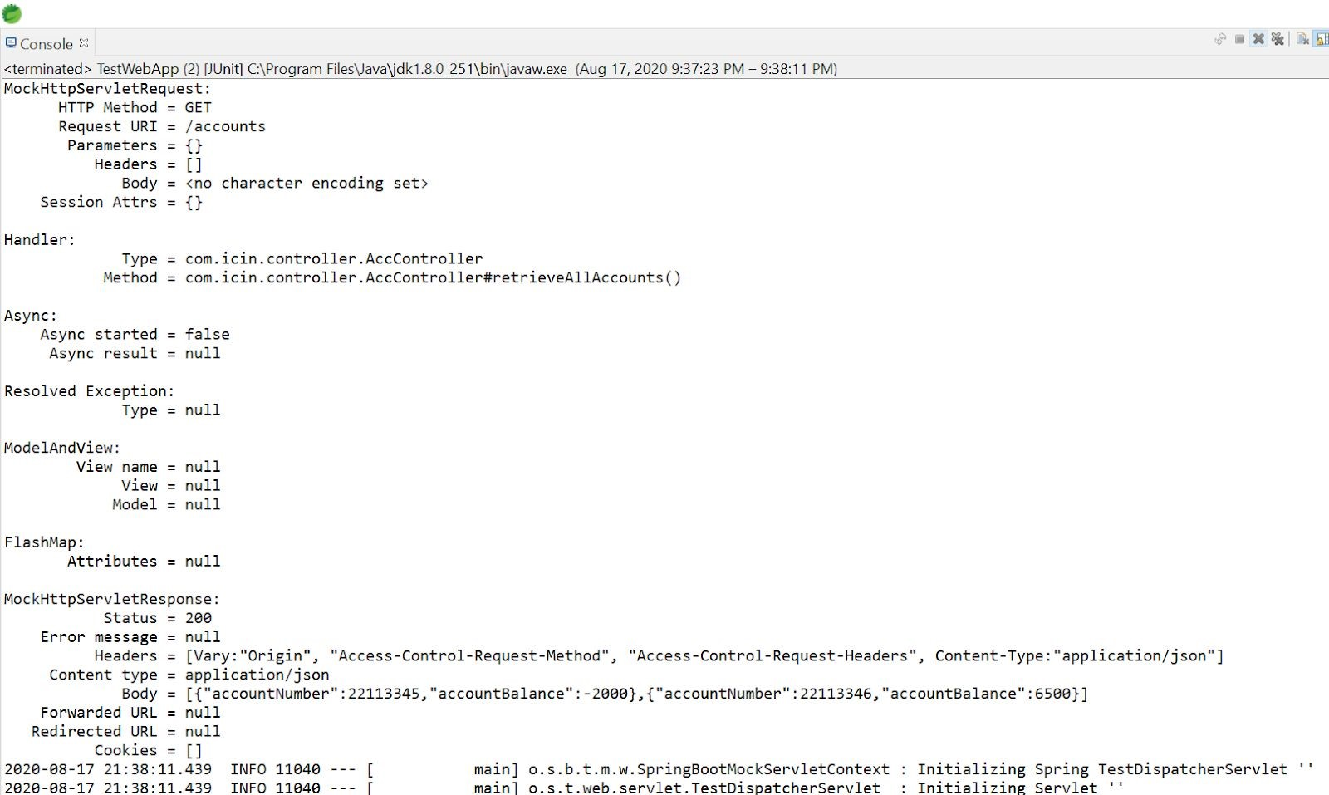

**TEST GET ALL TRANSACTION**

